# 基于Logstash的日志处理

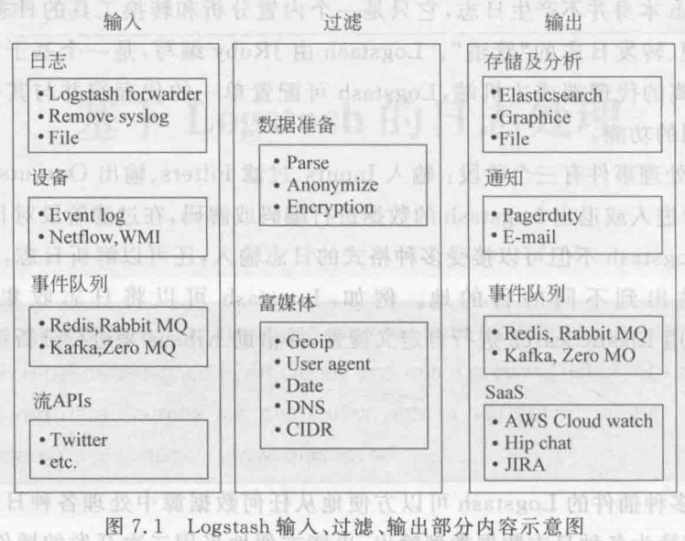

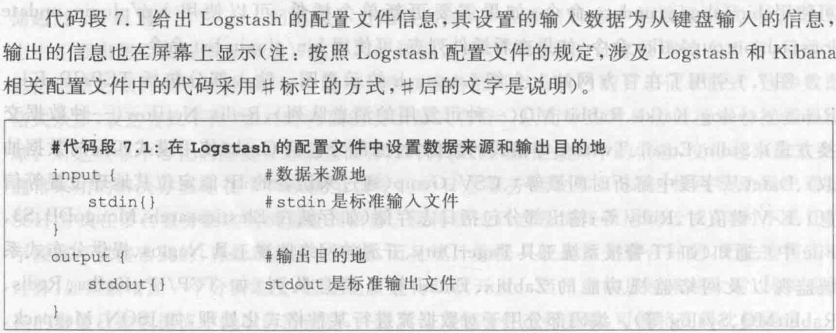

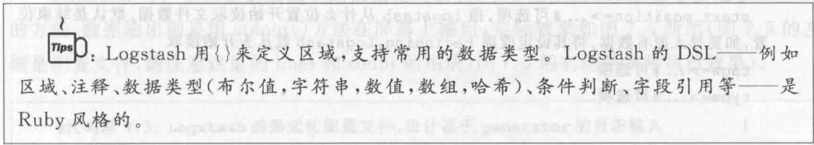

## 配置语法

### 1 语法

#### 1 区段

用 {} 表示

bin/logstash -e 'input { stdin { } } output { stdout {} }'

#### 2 数据类型

1. 布尔值 . debug => true
2. 字符串 . host => “localhost”
3. 数值 . port => 9600
4. 数组 . match => [“a”,”b”,”c”]
5. 哈希 .

options => {

Key1 => “v1”,

Key2 => “v2”

}

#### 3 字段引用

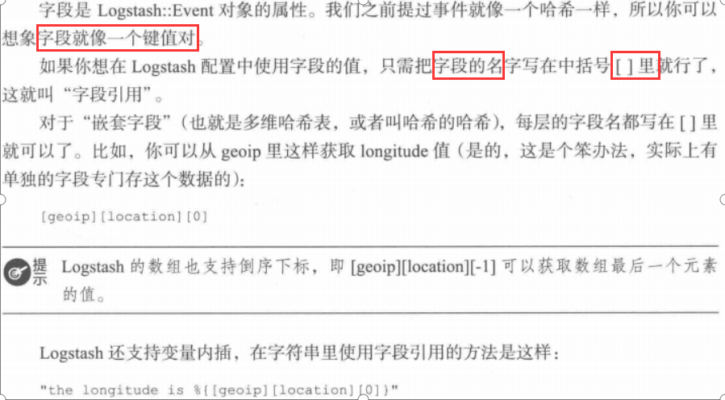

#### 4 条件判断

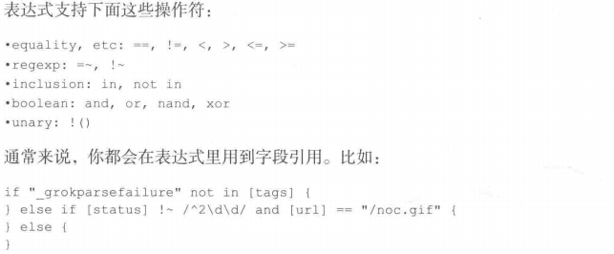

### 2 命令行参数

Logstash提供一个叫 logstash的脚本方便运行,支持的参数如下:

#### -e

执行

bin/logstash -e 'input { stdin { } } output { stdout {} }'

#### --config 或 -f

指定读取的配置文件,如

bin/logstash -f config/logstash.conf

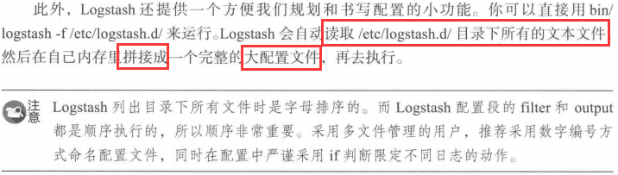

#### --configtest 或 -t

测试配置文件是否正确

#### --log 或 -l

Logstash默认将日志输出到标准错误,可使用 -l 指定输出位置

#### -w

运行filter和output线程数量,默认为cpu核数

#### -b

Logstash pipeline线程,在执行具体的filter和output函数前最多累计的日志条数,默认125条

#### -u

每个logstash pipeline线程在打包批量日志的时候,最多等待的时间(ms),默认5ms

#### -P

加载指定目录下的插件

bin/logstash -P /path/to/own/plugins

### 3 插件安装

bin/logstash-plugin install|uninstall|update|list 模块名

### 4 后台运行logstash

#### 1 标准的service方式

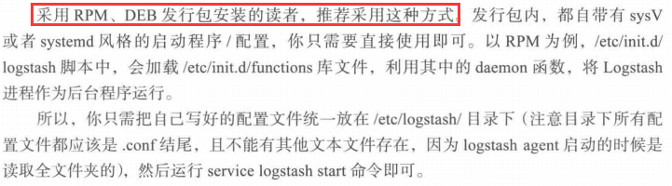

#### 2 最基础的nohup方式

类似如下命令

nohup shell命令 &> /dev/null

#### 3 更优雅的screen方式

https://www.ibm.com/developerworks/cn/linux/l-cn-screen/

## Input插件 - 数据输入

### 1处理file文件输入



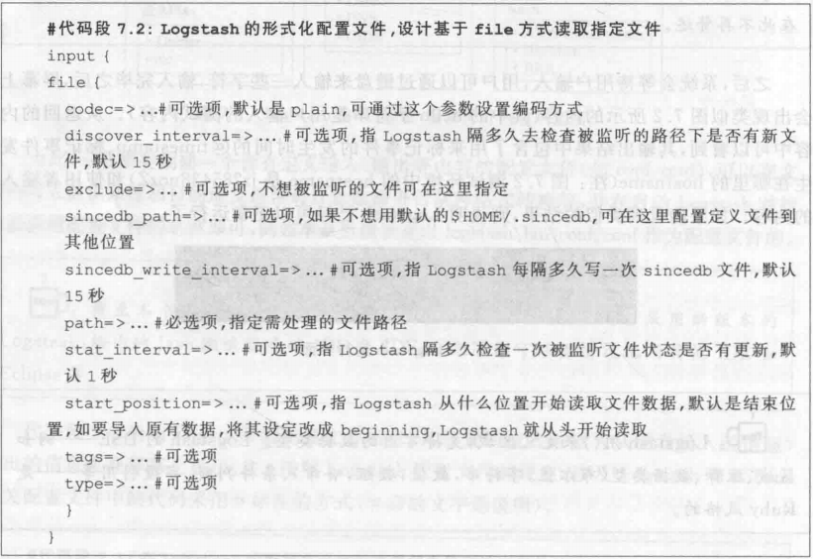

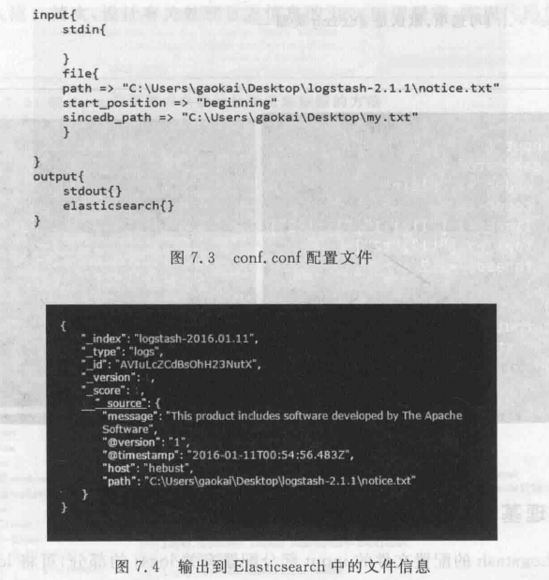

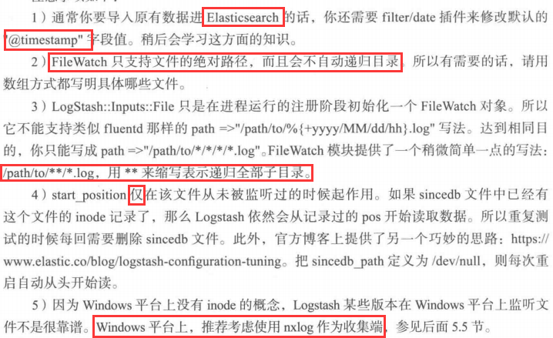

### 2 处理基于generator产生的日志

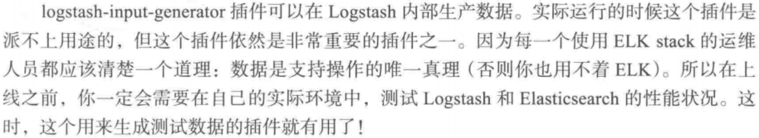

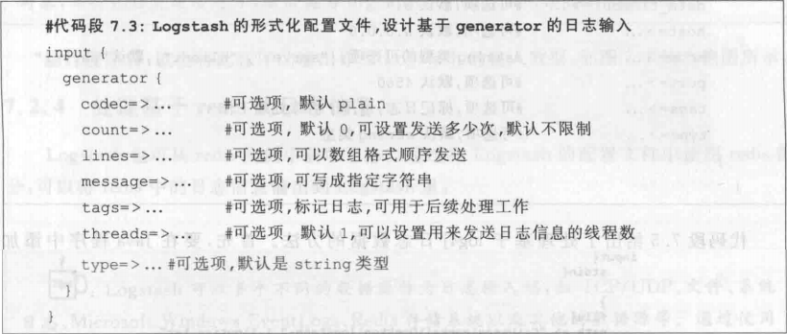

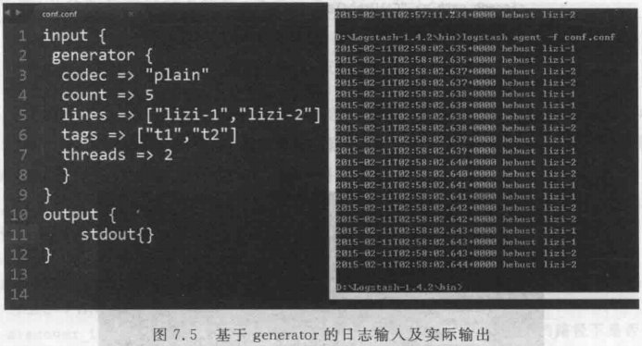

### 3 处理基于log4j的日志



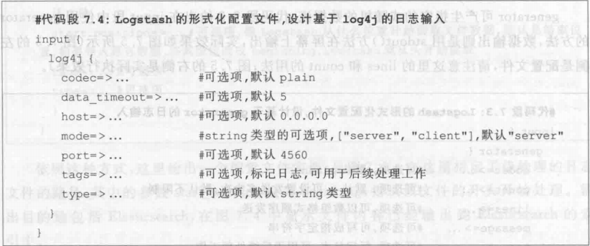

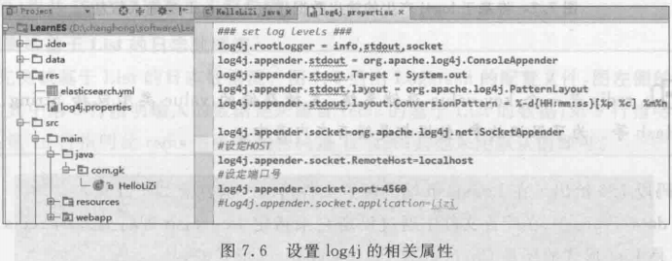

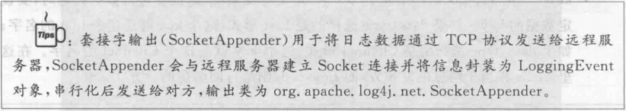

### 4 处理基于redis的日志信息

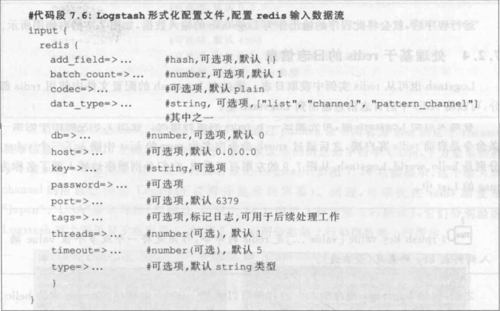

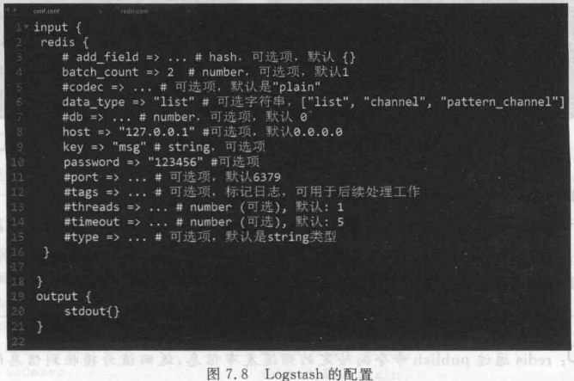

### 5 处理基于TCP传输的日志

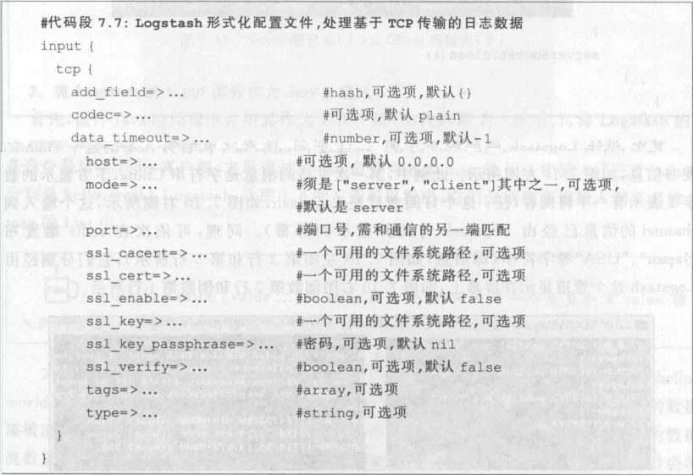

#### 1 将logstash的input部分作为client模式

Tcp的服务端使用java代码实现,logstash作为客户端接收

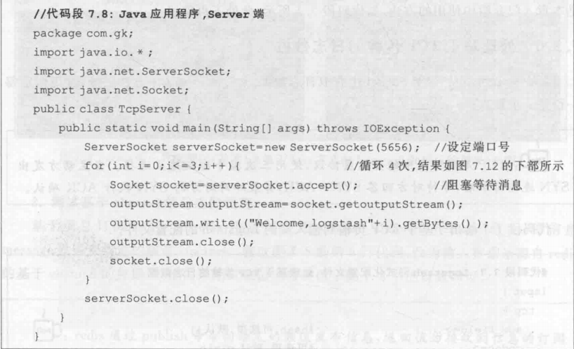

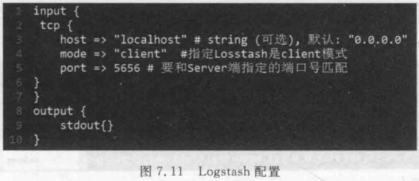

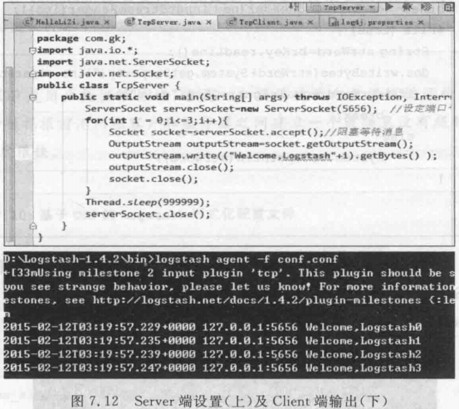

#### 2 将logstash的input部分作为server模式

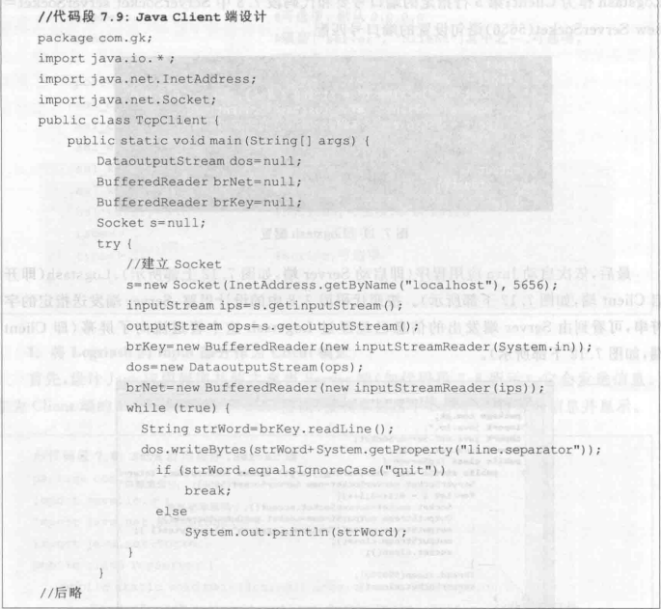

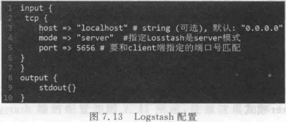

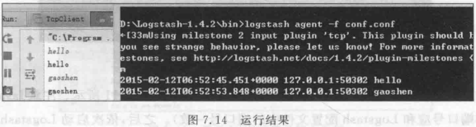

### 6 处理基于UDP传输的日志数据

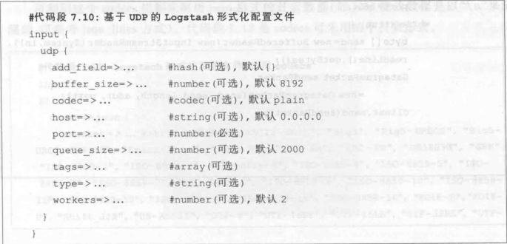

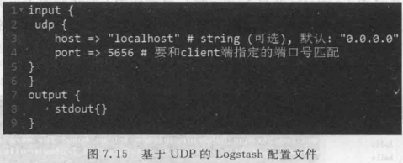

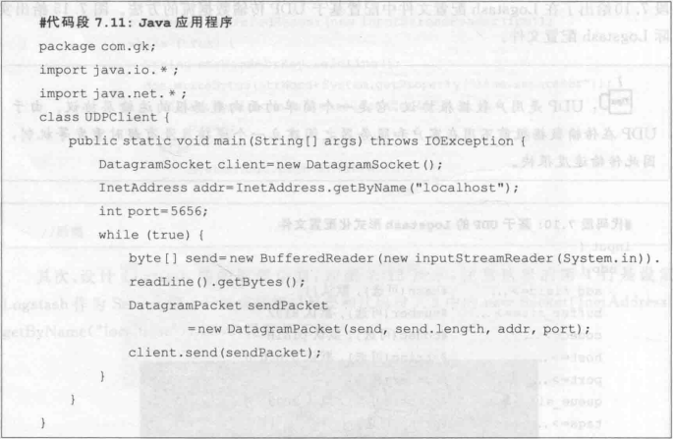

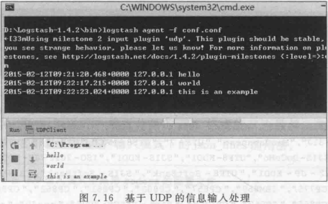

## Codecs 格式化日志数据

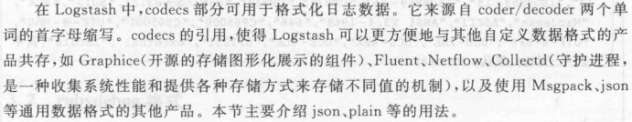

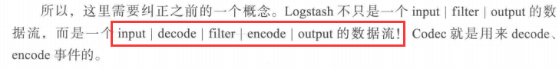

### 1 json 格式



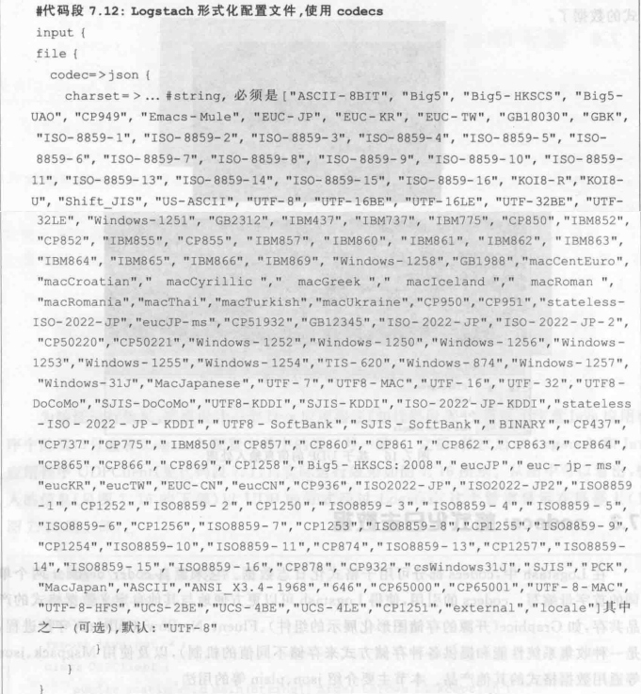

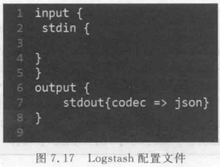

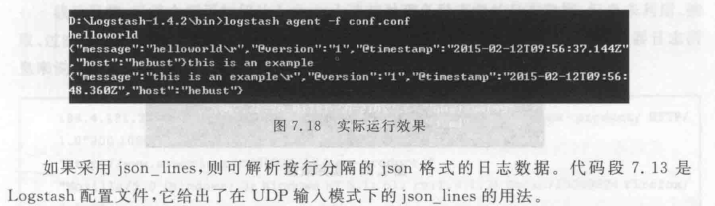

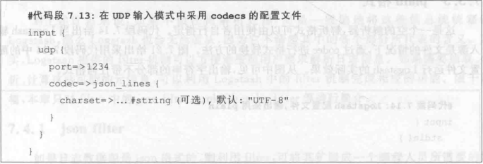

### 2 rubydebug格式

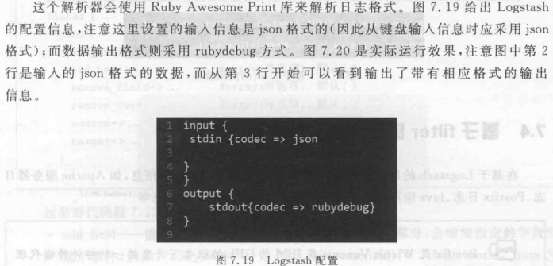

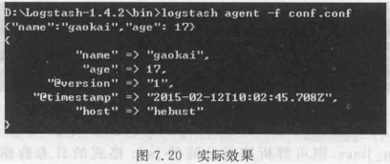

### 3 plain格式

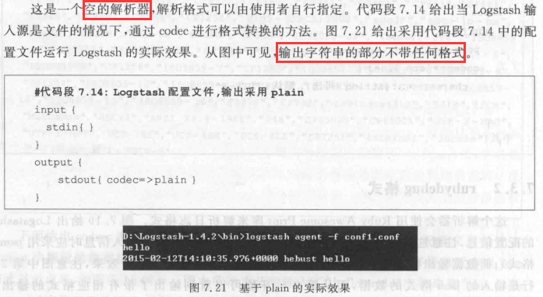

### 4 multiline 多行事件编码

<https://www.elastic.co/guide/en/logstash/current/plugins-codecs-multiline.html>

input {

stdin {

codec => multiline {

pattern => "pattern, a regexp"

negate => "true" or "false"

what => "previous" or "next"

}

}

}

|  |  |  |
| --- | --- | --- |
| [auto\_flush\_interval](https://www.elastic.co/guide/en/logstash/current/plugins-codecs-multiline.html" \l "plugins-codecs-multiline-auto_flush_interval" \o "auto_flush_interval) | [number](https://www.elastic.co/guide/en/logstash/current/configuration-file-structure.html" \l "number" \o "Numberedit) | No |
| [charset](https://www.elastic.co/guide/en/logstash/current/plugins-codecs-multiline.html" \l "plugins-codecs-multiline-charset" \o "charset) | [string](https://www.elastic.co/guide/en/logstash/current/configuration-file-structure.html" \l "string" \o "Stringedit), one of ["ASCII-8BIT", "UTF-8", "US-ASCII", "Big5", "Big5-HKSCS", "Big5-UAO", "CP949", "Emacs-Mule", "EUC-JP", "EUC-KR", "EUC-TW", "GB2312", "GB18030", "GBK", "ISO-8859-1", "ISO-8859-2", "ISO-8859-3", "ISO-8859-4", "ISO-8859-5", "ISO-8859-6", "ISO-8859-7", "ISO-8859-8", "ISO-8859-9", "ISO-8859-10", "ISO-8859-11", "ISO-8859-13", "ISO-8859-14", "ISO-8859-15", "ISO-8859-16", "KOI8-R", "KOI8-U", "Shift\_JIS", "UTF-16BE", "UTF-16LE", "UTF-32BE", "UTF-32LE", "Windows-31J", "Windows-1250", "Windows-1251", "Windows-1252", "IBM437", "IBM737", "IBM775", "CP850", "IBM852", "CP852", "IBM855", "CP855", "IBM857", "IBM860", "IBM861", "IBM862", "IBM863", "IBM864", "IBM865", "IBM866", "IBM869", "Windows-1258", "GB1988", "macCentEuro", "macCroatian", "macCyrillic", "macGreek", "macIceland", "macRoman", "macRomania", "macThai", "macTurkish", "macUkraine", "CP950", "CP951", "IBM037", "stateless-ISO-2022-JP", "eucJP-ms", "CP51932", "EUC-JIS-2004", "GB12345", "ISO-2022-JP", "ISO-2022-JP-2", "CP50220", "CP50221", "Windows-1256", "Windows-1253", "Windows-1255", "Windows-1254", "TIS-620", "Windows-874", "Windows-1257", "MacJapanese", "UTF-7", "UTF8-MAC", "UTF-16", "UTF-32", "UTF8-DoCoMo", "SJIS-DoCoMo", "UTF8-KDDI", "SJIS-KDDI", "ISO-2022-JP-KDDI", "stateless-ISO-2022-JP-KDDI", "UTF8-SoftBank", "SJIS-SoftBank", "BINARY", "CP437", "CP737", "CP775", "IBM850", "CP857", "CP860", "CP861", "CP862", "CP863", "CP864", "CP865", "CP866", "CP869", "CP1258", "Big5-HKSCS:2008", "ebcdic-cp-us", "eucJP", "euc-jp-ms", "EUC-JISX0213", "eucKR", "eucTW", "EUC-CN", "eucCN", "CP936", "ISO2022-JP", "ISO2022-JP2", "ISO8859-1", "ISO8859-2", "ISO8859-3", "ISO8859-4", "ISO8859-5", "ISO8859-6", "CP1256", "ISO8859-7", "CP1253", "ISO8859-8", "CP1255", "ISO8859-9", "CP1254", "ISO8859-10", "ISO8859-11", "CP874", "ISO8859-13", "CP1257", "ISO8859-14", "ISO8859-15", "ISO8859-16", "CP878", "MacJapan", "ASCII", "ANSI\_X3.4-1968", "646", "CP65000", "CP65001", "UTF-8-MAC", "UTF-8-HFS", "UCS-2BE", "UCS-4BE", "UCS-4LE", "CP932", "csWindows31J", "SJIS", "PCK", "CP1250", "CP1251", "CP1252", "external", "locale"] | No |
| [max\_bytes](https://www.elastic.co/guide/en/logstash/current/plugins-codecs-multiline.html" \l "plugins-codecs-multiline-max_bytes" \o "max_bytes) | [bytes](https://www.elastic.co/guide/en/logstash/current/configuration-file-structure.html" \l "bytes" \o "Bytesedit) | No |
| [max\_lines](https://www.elastic.co/guide/en/logstash/current/plugins-codecs-multiline.html" \l "plugins-codecs-multiline-max_lines" \o "max_lines) | [number](https://www.elastic.co/guide/en/logstash/current/configuration-file-structure.html" \l "number" \o "Numberedit) | No |
| [multiline\_tag](https://www.elastic.co/guide/en/logstash/current/plugins-codecs-multiline.html" \l "plugins-codecs-multiline-multiline_tag" \o "multiline_tag) | [string](https://www.elastic.co/guide/en/logstash/current/configuration-file-structure.html" \l "string" \o "Stringedit) | No |
| [negate](https://www.elastic.co/guide/en/logstash/current/plugins-codecs-multiline.html" \l "plugins-codecs-multiline-negate" \o "negate) | [boolean](https://www.elastic.co/guide/en/logstash/current/configuration-file-structure.html" \l "boolean" \o "Booleanedit) | No |
| [pattern](https://www.elastic.co/guide/en/logstash/current/plugins-codecs-multiline.html" \l "plugins-codecs-multiline-pattern" \o "pattern) | [string](https://www.elastic.co/guide/en/logstash/current/configuration-file-structure.html" \l "string" \o "Stringedit) | Yes |
| [patterns\_dir](https://www.elastic.co/guide/en/logstash/current/plugins-codecs-multiline.html" \l "plugins-codecs-multiline-patterns_dir" \o "patterns_dir) | [array](https://www.elastic.co/guide/en/logstash/current/configuration-file-structure.html" \l "array" \o "Array) | No |
| [what](https://www.elastic.co/guide/en/logstash/current/plugins-codecs-multiline.html" \l "plugins-codecs-multiline-what" \o "what) | [string](https://www.elastic.co/guide/en/logstash/current/configuration-file-structure.html" \l "string" \o "Stringedit), one of ["previous", "next"] | Yes |



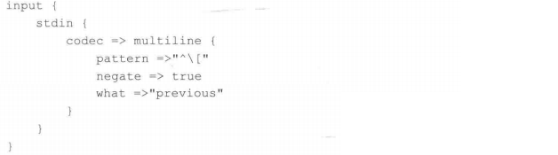

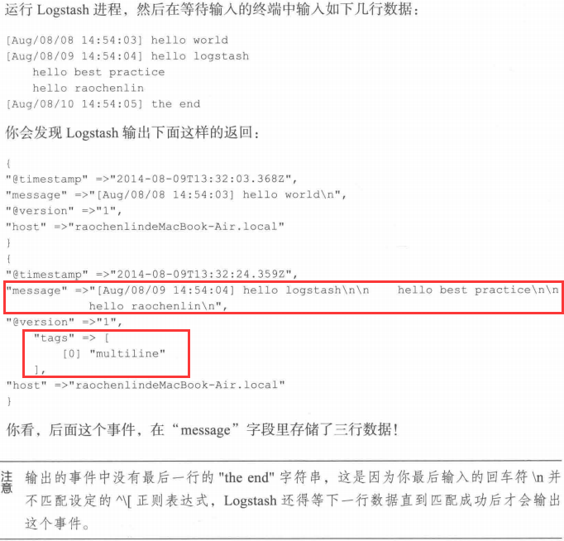

## 基于filter的日志处理和转换





### 1 json filter

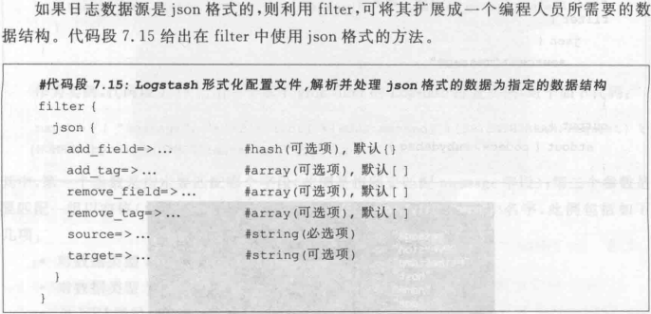

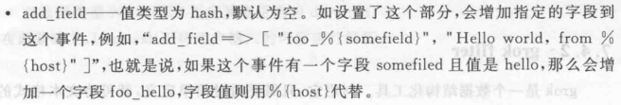

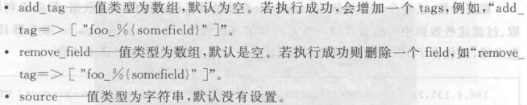

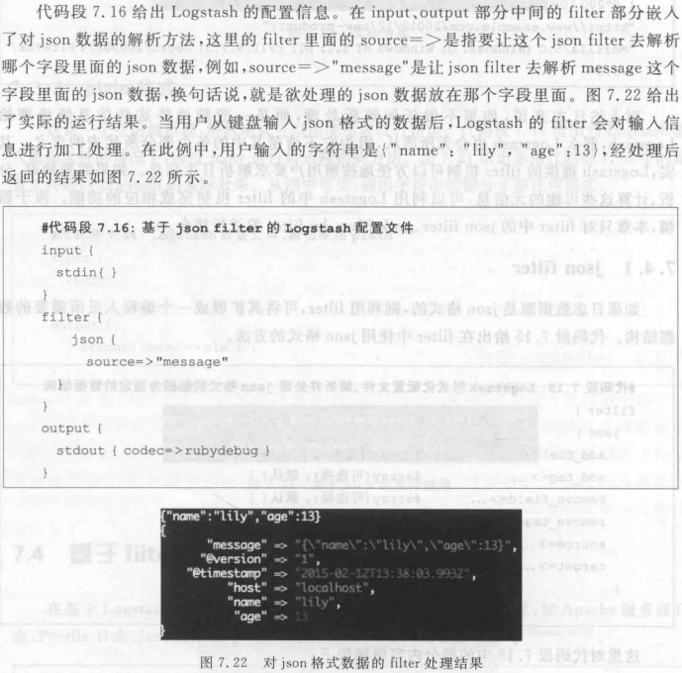

### 2 grok filter

<https://github.com/logstash-plugins/logstash-patterns-core/blob/master/patterns/grok-patterns>



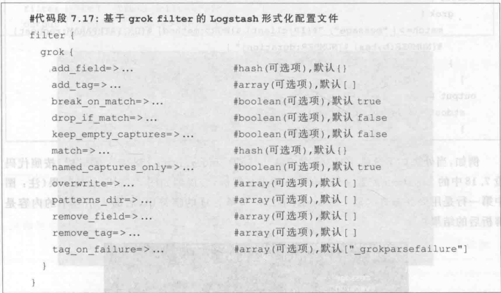

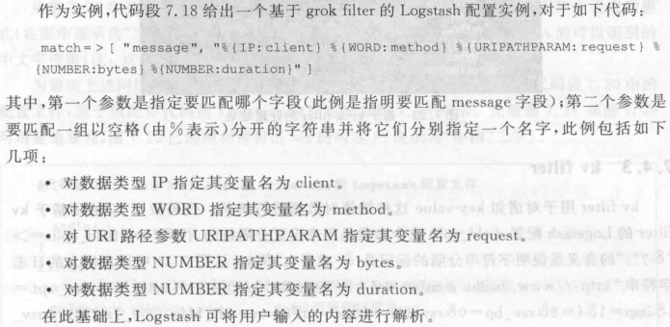

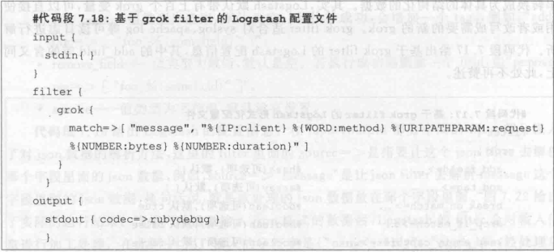

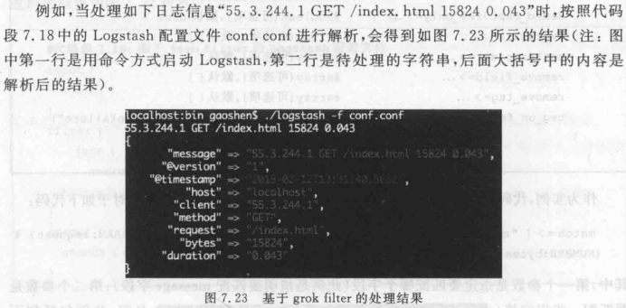

55.3.244.1 GET /index.html 15824 0.043

input {

file {

path => "/var/log/http.log"

}

}

filter {

grok {

match => { "message" => "%{IP:client} %{WORD:method} %{URIPATHPARAM:request} %{NUMBER:bytes} %{NUMBER:duration}" }

}

}

* client: 55.3.244.1
* method: GET
* request: /index.html
* bytes: 15824
* duration: 0.043

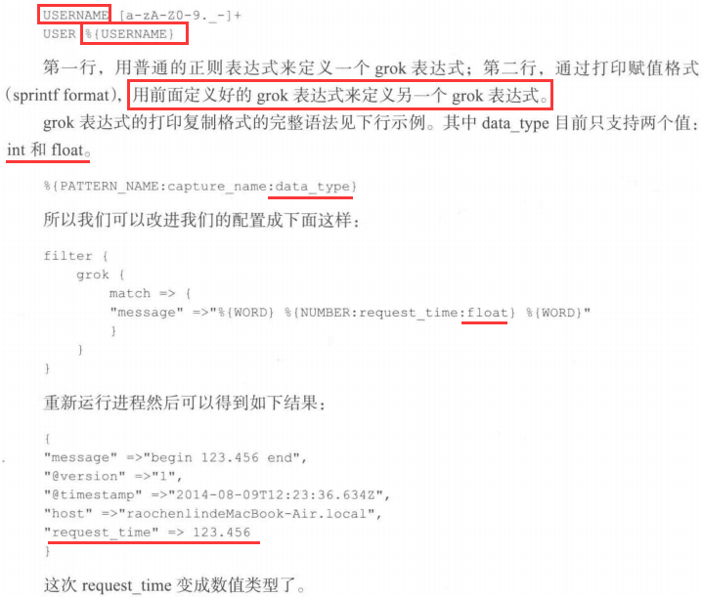

#### 官方预定义的grok表达式

|  |
| --- |
| USERNAME [a-zA-Z0-9.\_-]+ |
| USER %{USERNAME} |
| EMAILLOCALPART [a-zA-Z][a-zA-Z0-9\_.+-=:]+ |
| EMAILADDRESS %{EMAILLOCALPART}@%{HOSTNAME} |
| INT (?:[+-]?(?:[0-9]+)) |
| BASE10NUM (?<![0-9.+-])(?>[+-]?(?:(?:[0-9]+(?:\.[0-9]+)?)|(?:\.[0-9]+))) |
| NUMBER (?:%{BASE10NUM}) |
| BASE16NUM (?<![0-9A-Fa-f])(?:[+-]?(?:0x)?(?:[0-9A-Fa-f]+)) |
| BASE16FLOAT \b(?<![0-9A-Fa-f.])(?:[+-]?(?:0x)?(?:(?:[0-9A-Fa-f]+(?:\.[0-9A-Fa-f]\*)?)|(?:\.[0-9A-Fa-f]+)))\b |
|  |
| POSINT \b(?:[1-9][0-9]\*)\b |
| NONNEGINT \b(?:[0-9]+)\b |
| WORD \b\w+\b |
| NOTSPACE \S+ |
| SPACE \s\* |
| DATA .\*? |
| GREEDYDATA .\* |
| QUOTEDSTRING (?>(?<!\\)(?>"(?>\\.|[^\\"]+)+"|""|(?>'(?>\\.|[^\\']+)+')|''|(?>`(?>\\.|[^\\`]+)+`)|``)) |
| UUID [A-Fa-f0-9]{8}-(?:[A-Fa-f0-9]{4}-){3}[A-Fa-f0-9]{12} |
| # URN, allowing use of RFC 2141 section 2.3 reserved characters |
| URN urn:[0-9A-Za-z][0-9A-Za-z-]{0,31}:(?:%[0-9a-fA-F]{2}|[0-9A-Za-z()+,.:=@;$\_!\*'/?#-])+ |
|  |
| # Networking |
| MAC (?:%{CISCOMAC}|%{WINDOWSMAC}|%{COMMONMAC}) |
| CISCOMAC (?:(?:[A-Fa-f0-9]{4}\.){2}[A-Fa-f0-9]{4}) |
| WINDOWSMAC (?:(?:[A-Fa-f0-9]{2}-){5}[A-Fa-f0-9]{2}) |
| COMMONMAC (?:(?:[A-Fa-f0-9]{2}:){5}[A-Fa-f0-9]{2}) |
| IPV6 ((([0-9A-Fa-f]{1,4}:){7}([0-9A-Fa-f]{1,4}|:))|(([0-9A-Fa-f]{1,4}:){6}(:[0-9A-Fa-f]{1,4}|((25[0-5]|2[0-4]\d|1\d\d|[1-9]?\d)(\.(25[0-5]|2[0-4]\d|1\d\d|[1-9]?\d)){3})|:))|(([0-9A-Fa-f]{1,4}:){5}(((:[0-9A-Fa-f]{1,4}){1,2})|:((25[0-5]|2[0-4]\d|1\d\d|[1-9]?\d)(\.(25[0-5]|2[0-4]\d|1\d\d|[1-9]?\d)){3})|:))|(([0-9A-Fa-f]{1,4}:){4}(((:[0-9A-Fa-f]{1,4}){1,3})|((:[0-9A-Fa-f]{1,4})?:((25[0-5]|2[0-4]\d|1\d\d|[1-9]?\d)(\.(25[0-5]|2[0-4]\d|1\d\d|[1-9]?\d)){3}))|:))|(([0-9A-Fa-f]{1,4}:){3}(((:[0-9A-Fa-f]{1,4}){1,4})|((:[0-9A-Fa-f]{1,4}){0,2}:((25[0-5]|2[0-4]\d|1\d\d|[1-9]?\d)(\.(25[0-5]|2[0-4]\d|1\d\d|[1-9]?\d)){3}))|:))|(([0-9A-Fa-f]{1,4}:){2}(((:[0-9A-Fa-f]{1,4}){1,5})|((:[0-9A-Fa-f]{1,4}){0,3}:((25[0-5]|2[0-4]\d|1\d\d|[1-9]?\d)(\.(25[0-5]|2[0-4]\d|1\d\d|[1-9]?\d)){3}))|:))|(([0-9A-Fa-f]{1,4}:){1}(((:[0-9A-Fa-f]{1,4}){1,6})|((:[0-9A-Fa-f]{1,4}){0,4}:((25[0-5]|2[0-4]\d|1\d\d|[1-9]?\d)(\.(25[0-5]|2[0-4]\d|1\d\d|[1-9]?\d)){3}))|:))|(:(((:[0-9A-Fa-f]{1,4}){1,7})|((:[0-9A-Fa-f]{1,4}){0,5}:((25[0-5]|2[0-4]\d|1\d\d|[1-9]?\d)(\.(25[0-5]|2[0-4]\d|1\d\d|[1-9]?\d)){3}))|:)))(%.+)? |
| IPV4 (?<![0-9])(?:(?:[0-1]?[0-9]{1,2}|2[0-4][0-9]|25[0-5])[.](?:[0-1]?[0-9]{1,2}|2[0-4][0-9]|25[0-5])[.](?:[0-1]?[0-9]{1,2}|2[0-4][0-9]|25[0-5])[.](?:[0-1]?[0-9]{1,2}|2[0-4][0-9]|25[0-5]))(?![0-9]) |
| IP (?:%{IPV6}|%{IPV4}) |
| HOSTNAME \b(?:[0-9A-Za-z][0-9A-Za-z-]{0,62})(?:\.(?:[0-9A-Za-z][0-9A-Za-z-]{0,62}))\*(\.?|\b) |
| IPORHOST (?:%{IP}|%{HOSTNAME}) |
| HOSTPORT %{IPORHOST}:%{POSINT} |
|  |
| # paths |
| PATH (?:%{UNIXPATH}|%{WINPATH}) |
| UNIXPATH (/([\w\_%!$@:.,+~-]+|\\.)\*)+ |
| TTY (?:/dev/(pts|tty([pq])?)(\w+)?/?(?:[0-9]+)) |
| WINPATH (?>[A-Za-z]+:|\\)(?:\\[^\\?\*]\*)+ |
| URIPROTO [A-Za-z]([A-Za-z0-9+\-.]+)+ |
| URIHOST %{IPORHOST}(?::%{POSINT:port})? |
| # uripath comes loosely from RFC1738, but mostly from what Firefox |
| # doesn't turn into %XX |
| URIPATH (?:/[A-Za-z0-9$.+!\*'(){},~:;=@#%&\_\-]\*)+ |
| #URIPARAM \?(?:[A-Za-z0-9]+(?:=(?:[^&]\*))?(?:&(?:[A-Za-z0-9]+(?:=(?:[^&]\*))?)?)\*)? |
| URIPARAM \?[A-Za-z0-9$.+!\*'|(){},~@#%&/=:;\_?\-\[\]<>]\* |
| URIPATHPARAM %{URIPATH}(?:%{URIPARAM})? |
| URI %{URIPROTO}://(?:%{USER}(?::[^@]\*)?@)?(?:%{URIHOST})?(?:%{URIPATHPARAM})? |
|  |
| # Months: January, Feb, 3, 03, 12, December |
| MONTH \b(?:[Jj]an(?:uary|uar)?|[Ff]eb(?:ruary|ruar)?|[Mm](?:a|ä)?r(?:ch|z)?|[Aa]pr(?:il)?|[Mm]a(?:y|i)?|[Jj]un(?:e|i)?|[Jj]ul(?:y)?|[Aa]ug(?:ust)?|[Ss]ep(?:tember)?|[Oo](?:c|k)?t(?:ober)?|[Nn]ov(?:ember)?|[Dd]e(?:c|z)(?:ember)?)\b |
| MONTHNUM (?:0?[1-9]|1[0-2]) |
| MONTHNUM2 (?:0[1-9]|1[0-2]) |
| MONTHDAY (?:(?:0[1-9])|(?:[12][0-9])|(?:3[01])|[1-9]) |
|  |
| # Days: Monday, Tue, Thu, etc... |
| DAY (?:Mon(?:day)?|Tue(?:sday)?|Wed(?:nesday)?|Thu(?:rsday)?|Fri(?:day)?|Sat(?:urday)?|Sun(?:day)?) |
|  |
| # Years? |
| YEAR (?>\d\d){1,2} |
| HOUR (?:2[0123]|[01]?[0-9]) |
| MINUTE (?:[0-5][0-9]) |
| # '60' is a leap second in most time standards and thus is valid. |
| SECOND (?:(?:[0-5]?[0-9]|60)(?:[:.,][0-9]+)?) |
| TIME (?!<[0-9])%{HOUR}:%{MINUTE}(?::%{SECOND})(?![0-9]) |
| # datestamp is YYYY/MM/DD-HH:MM:SS.UUUU (or something like it) |
| DATE\_US %{MONTHNUM}[/-]%{MONTHDAY}[/-]%{YEAR} |
| DATE\_EU %{MONTHDAY}[./-]%{MONTHNUM}[./-]%{YEAR} |
| ISO8601\_TIMEZONE (?:Z|[+-]%{HOUR}(?::?%{MINUTE})) |
| ISO8601\_SECOND (?:%{SECOND}|60) |
| TIMESTAMP\_ISO8601 %{YEAR}-%{MONTHNUM}-%{MONTHDAY}[T ]%{HOUR}:?%{MINUTE}(?::?%{SECOND})?%{ISO8601\_TIMEZONE}? |
| DATE %{DATE\_US}|%{DATE\_EU} |
| DATESTAMP %{DATE}[- ]%{TIME} |
| TZ (?:[APMCE][SD]T|UTC) |
| DATESTAMP\_RFC822 %{DAY} %{MONTH} %{MONTHDAY} %{YEAR} %{TIME} %{TZ} |
| DATESTAMP\_RFC2822 %{DAY}, %{MONTHDAY} %{MONTH} %{YEAR} %{TIME} %{ISO8601\_TIMEZONE} |
| DATESTAMP\_OTHER %{DAY} %{MONTH} %{MONTHDAY} %{TIME} %{TZ} %{YEAR} |
| DATESTAMP\_EVENTLOG %{YEAR}%{MONTHNUM2}%{MONTHDAY}%{HOUR}%{MINUTE}%{SECOND} |
|  |
| # Syslog Dates: Month Day HH:MM:SS |
| SYSLOGTIMESTAMP %{MONTH} +%{MONTHDAY} %{TIME} |
| PROG [\x21-\x5a\x5c\x5e-\x7e]+ |
| SYSLOGPROG %{PROG:program}(?:\[%{POSINT:pid}\])? |
| SYSLOGHOST %{IPORHOST} |
| SYSLOGFACILITY <%{NONNEGINT:facility}.%{NONNEGINT:priority}> |
| HTTPDATE %{MONTHDAY}/%{MONTH}/%{YEAR}:%{TIME} %{INT} |
|  |
| # Shortcuts |
| QS %{QUOTEDSTRING} |
|  |
| # Log formats |
| SYSLOGBASE %{SYSLOGTIMESTAMP:timestamp} (?:%{SYSLOGFACILITY} )?%{SYSLOGHOST:logsource} %{SYSLOGPROG}: |
|  |
| # Log Levels |
| LOGLEVEL ([Aa]lert|ALERT|[Tt]race|TRACE|[Dd]ebug|DEBUG|[Nn]otice|NOTICE|[Ii]nfo|INFO|[Ww]arn?(?:ing)?|WARN?(?:ING)?|[Ee]rr?(?:or)?|ERR?(?:OR)?|[Cc]rit?(?:ical)?|CRIT?(?:ICAL)?|[Ff]atal|FATAL|[Ss]evere|SEVERE|EMERG(?:ENCY)?|[Ee]merg(?:ency)?) |

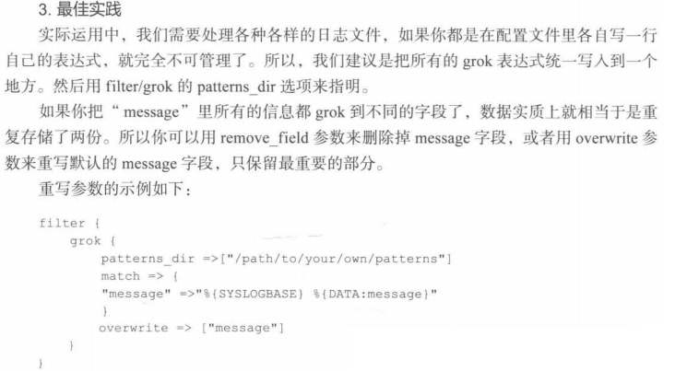

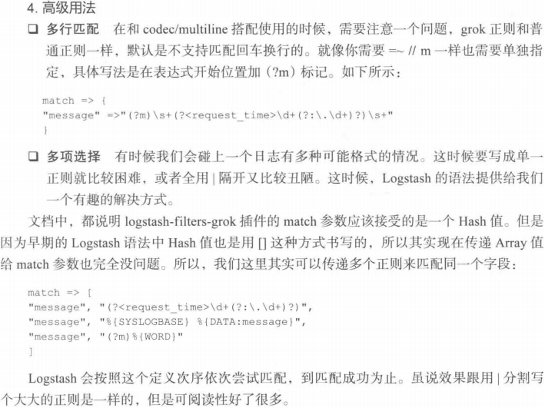

### 3 kv filter

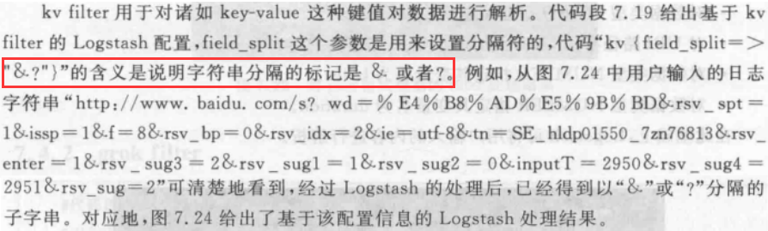

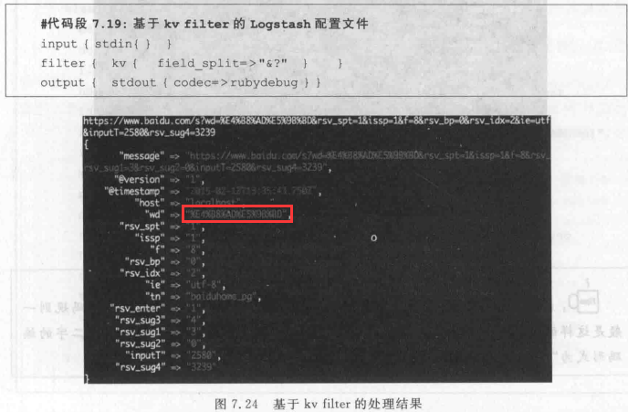

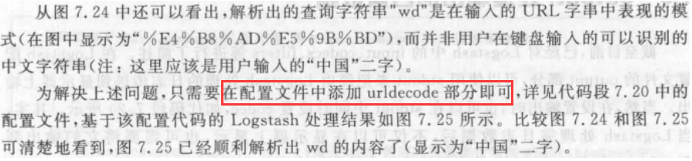

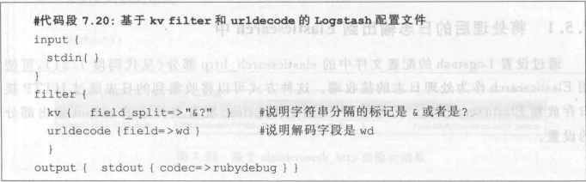

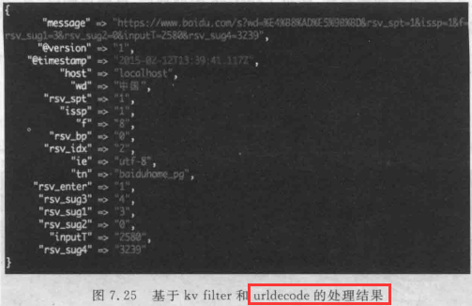

### 4 date filter

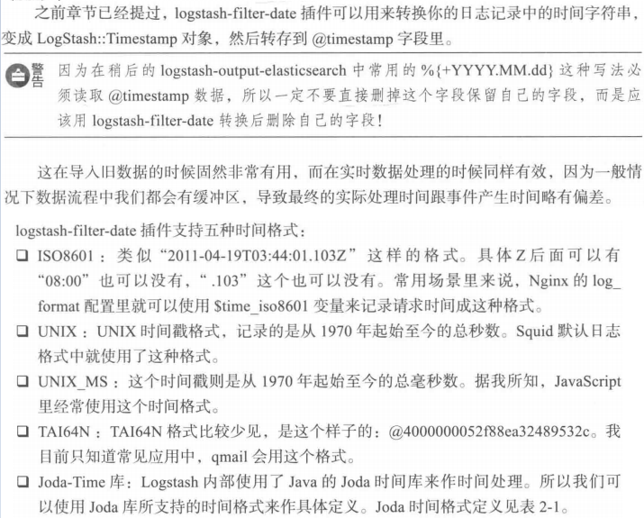

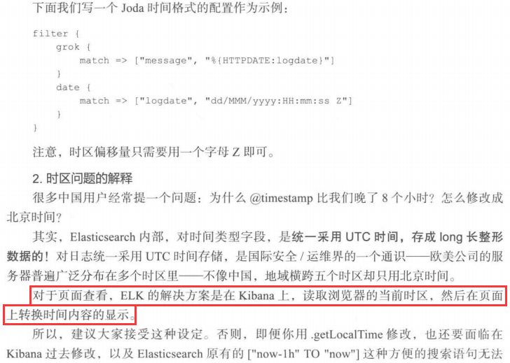

### 5 dissect 解析



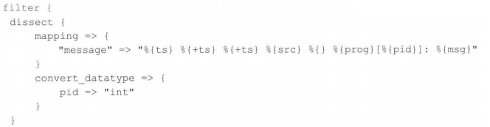

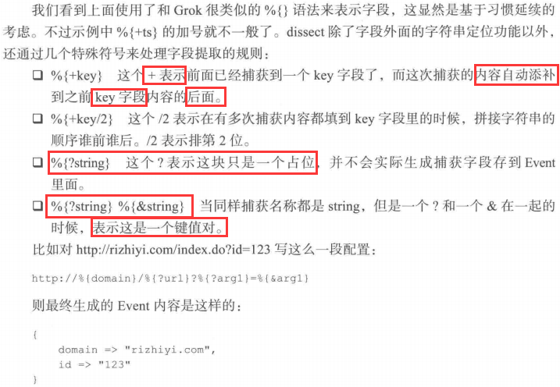

### 6 mutate 数据修改



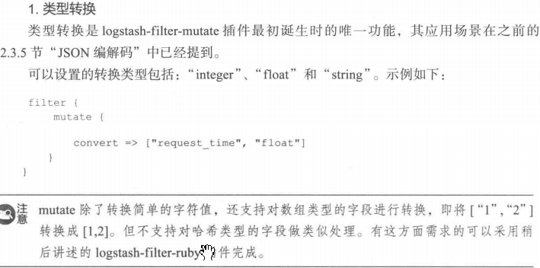

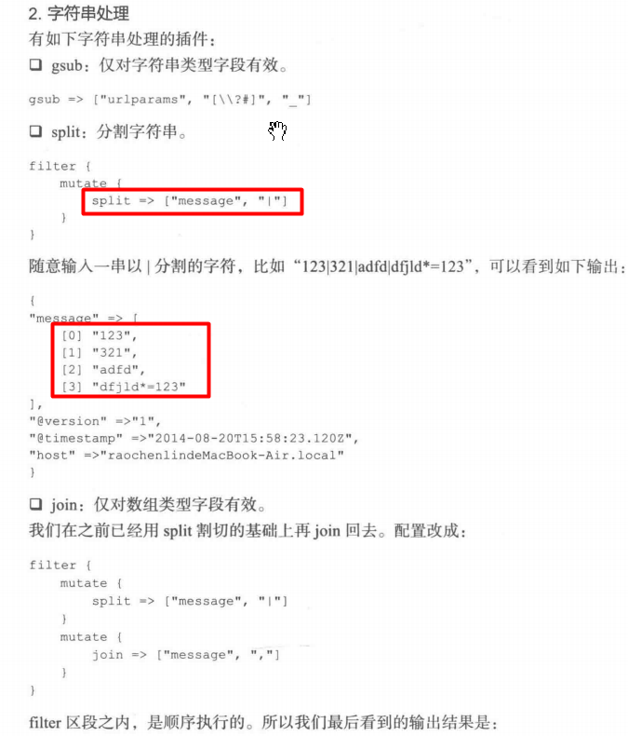

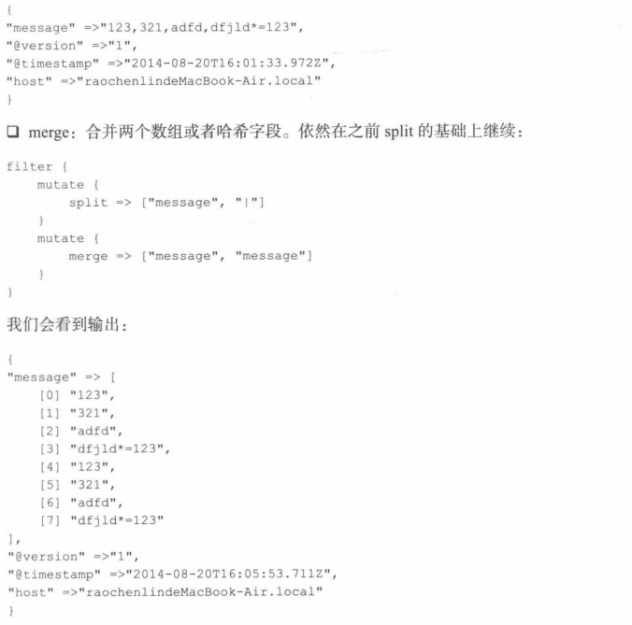

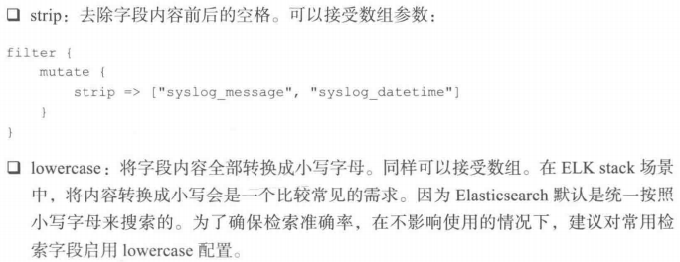

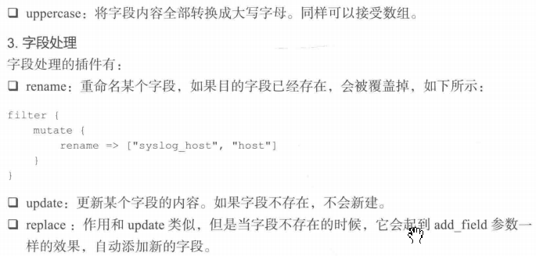

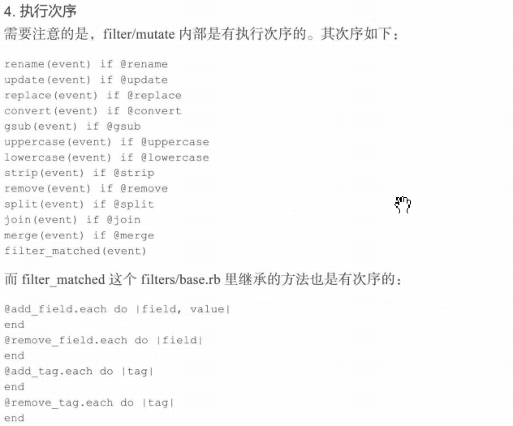

### 7 split拆分事件

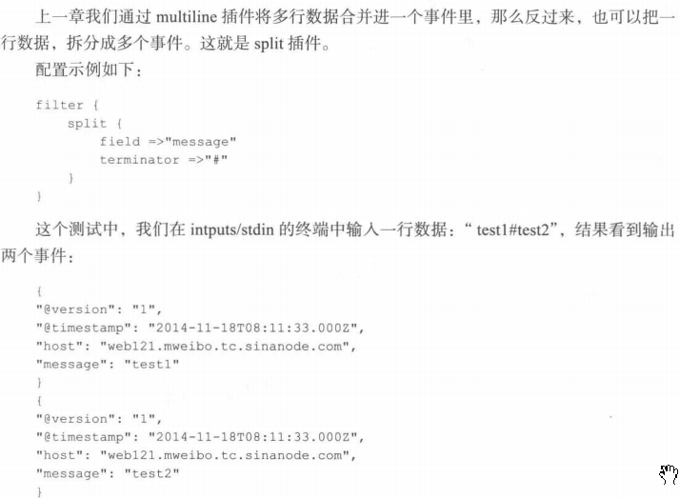

## Output插件 - 数据输出

### Common Options

The following configuration options are supported by all output plugins:

| **Setting** | **Input type** | **Required** |
| --- | --- | --- |
| [codec](https://www.elastic.co/guide/en/logstash/6.5/plugins-outputs-csv.html" \l "plugins-outputs-csv-codec" \o "codec) | [codec](http://www.elastic.co/guide/en/logstash/6.5/configuration-file-structure.html" \l "codec" \t "https://www.elastic.co/guide/en/logstash/6.5/_top) | No |
| [enable\_metric](https://www.elastic.co/guide/en/logstash/6.5/plugins-outputs-csv.html" \l "plugins-outputs-csv-enable_metric" \o "enable_metric) | [boolean](http://www.elastic.co/guide/en/logstash/6.5/configuration-file-structure.html" \l "boolean" \t "https://www.elastic.co/guide/en/logstash/6.5/_top) | No |
| [id](https://www.elastic.co/guide/en/logstash/6.5/plugins-outputs-csv.html" \l "plugins-outputs-csv-id" \o "id) | [string](http://www.elastic.co/guide/en/logstash/6.5/configuration-file-structure.html" \l "string" \t "https://www.elastic.co/guide/en/logstash/6.5/_top) | No |

### 1 Elasticsearch 输出到Elasticsearch中

https://www.elastic.co/guide/en/logstash/6.5/plugins-outputs-elasticsearch.html

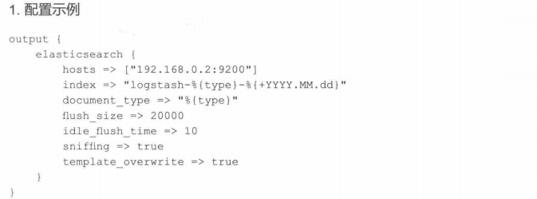

| **Setting** | **Input type** | **Required** |
| --- | --- | --- |
| [action](https://www.elastic.co/guide/en/logstash/6.5/plugins-outputs-elasticsearch.html" \l "plugins-outputs-elasticsearch-action" \o "action) | [string](https://www.elastic.co/guide/en/logstash/6.5/configuration-file-structure.html" \l "string" \o "Stringedit) | No |
| [bulk\_path](https://www.elastic.co/guide/en/logstash/6.5/plugins-outputs-elasticsearch.html" \l "plugins-outputs-elasticsearch-bulk_path" \o "bulk_path) | [string](https://www.elastic.co/guide/en/logstash/6.5/configuration-file-structure.html" \l "string" \o "Stringedit) | No |
| [cacert](https://www.elastic.co/guide/en/logstash/6.5/plugins-outputs-elasticsearch.html" \l "plugins-outputs-elasticsearch-cacert" \o "cacert) | a valid filesystem path | No |
| [custom\_headers](https://www.elastic.co/guide/en/logstash/6.5/plugins-outputs-elasticsearch.html" \l "plugins-outputs-elasticsearch-custom_headers" \o "custom_headers) | [hash](https://www.elastic.co/guide/en/logstash/6.5/configuration-file-structure.html" \l "hash" \o "Hashedit) | No |
| [doc\_as\_upsert](https://www.elastic.co/guide/en/logstash/6.5/plugins-outputs-elasticsearch.html" \l "plugins-outputs-elasticsearch-doc_as_upsert" \o "doc_as_upsert) | [boolean](https://www.elastic.co/guide/en/logstash/6.5/configuration-file-structure.html" \l "boolean" \o "Booleanedit) | No |
| [document\_id](https://www.elastic.co/guide/en/logstash/6.5/plugins-outputs-elasticsearch.html" \l "plugins-outputs-elasticsearch-document_id" \o "document_id) | [string](https://www.elastic.co/guide/en/logstash/6.5/configuration-file-structure.html" \l "string" \o "Stringedit) | No |
| [document\_type](https://www.elastic.co/guide/en/logstash/6.5/plugins-outputs-elasticsearch.html" \l "plugins-outputs-elasticsearch-document_type" \o "document_type) | [string](https://www.elastic.co/guide/en/logstash/6.5/configuration-file-structure.html" \l "string" \o "Stringedit) | No |
| [failure\_type\_logging\_whitelist](https://www.elastic.co/guide/en/logstash/6.5/plugins-outputs-elasticsearch.html" \l "plugins-outputs-elasticsearch-failure_type_logging_whitelist" \o "failure_type_logging_whitelist) | [array](https://www.elastic.co/guide/en/logstash/6.5/configuration-file-structure.html" \l "array" \o "Array) | No |
| [healthcheck\_path](https://www.elastic.co/guide/en/logstash/6.5/plugins-outputs-elasticsearch.html" \l "plugins-outputs-elasticsearch-healthcheck_path" \o "healthcheck_path) | [string](https://www.elastic.co/guide/en/logstash/6.5/configuration-file-structure.html" \l "string" \o "Stringedit) | No |
| [hosts](https://www.elastic.co/guide/en/logstash/6.5/plugins-outputs-elasticsearch.html" \l "plugins-outputs-elasticsearch-hosts" \o "hosts) | [uri](https://www.elastic.co/guide/en/logstash/6.5/configuration-file-structure.html" \l "uri" \o "URIedit) | No |
| [http\_compression](https://www.elastic.co/guide/en/logstash/6.5/plugins-outputs-elasticsearch.html" \l "plugins-outputs-elasticsearch-http_compression" \o "http_compression) | [boolean](https://www.elastic.co/guide/en/logstash/6.5/configuration-file-structure.html" \l "boolean" \o "Booleanedit) | No |
| [index](https://www.elastic.co/guide/en/logstash/6.5/plugins-outputs-elasticsearch.html" \l "plugins-outputs-elasticsearch-index" \o "index) | [string](https://www.elastic.co/guide/en/logstash/6.5/configuration-file-structure.html" \l "string" \o "Stringedit) | No |
| [keystore](https://www.elastic.co/guide/en/logstash/6.5/plugins-outputs-elasticsearch.html" \l "plugins-outputs-elasticsearch-keystore" \o "keystore) | a valid filesystem path | No |
| [keystore\_password](https://www.elastic.co/guide/en/logstash/6.5/plugins-outputs-elasticsearch.html" \l "plugins-outputs-elasticsearch-keystore_password" \o "keystore_password) | [password](https://www.elastic.co/guide/en/logstash/6.5/configuration-file-structure.html" \l "password" \o "Passwordedit) | No |
| [manage\_template](https://www.elastic.co/guide/en/logstash/6.5/plugins-outputs-elasticsearch.html" \l "plugins-outputs-elasticsearch-manage_template" \o "manage_template) | [boolean](https://www.elastic.co/guide/en/logstash/6.5/configuration-file-structure.html" \l "boolean" \o "Booleanedit) | No |
| [parameters](https://www.elastic.co/guide/en/logstash/6.5/plugins-outputs-elasticsearch.html" \l "plugins-outputs-elasticsearch-parameters" \o "parameters) | [hash](https://www.elastic.co/guide/en/logstash/6.5/configuration-file-structure.html" \l "hash" \o "Hashedit) | No |
| [parent](https://www.elastic.co/guide/en/logstash/6.5/plugins-outputs-elasticsearch.html" \l "plugins-outputs-elasticsearch-parent" \o "parent) | [string](https://www.elastic.co/guide/en/logstash/6.5/configuration-file-structure.html" \l "string" \o "Stringedit) | No |
| [password](https://www.elastic.co/guide/en/logstash/6.5/plugins-outputs-elasticsearch.html" \l "plugins-outputs-elasticsearch-password" \o "password) | [password](https://www.elastic.co/guide/en/logstash/6.5/configuration-file-structure.html" \l "password" \o "Passwordedit) | No |
| [path](https://www.elastic.co/guide/en/logstash/6.5/plugins-outputs-elasticsearch.html" \l "plugins-outputs-elasticsearch-path" \o "path) | [string](https://www.elastic.co/guide/en/logstash/6.5/configuration-file-structure.html" \l "string" \o "Stringedit) | No |
| [pipeline](https://www.elastic.co/guide/en/logstash/6.5/plugins-outputs-elasticsearch.html" \l "plugins-outputs-elasticsearch-pipeline" \o "pipeline) | [string](https://www.elastic.co/guide/en/logstash/6.5/configuration-file-structure.html" \l "string" \o "Stringedit) | No |
| [pool\_max](https://www.elastic.co/guide/en/logstash/6.5/plugins-outputs-elasticsearch.html" \l "plugins-outputs-elasticsearch-pool_max" \o "pool_max) | [number](https://www.elastic.co/guide/en/logstash/6.5/configuration-file-structure.html" \l "number" \o "Numberedit) | No |
| [pool\_max\_per\_route](https://www.elastic.co/guide/en/logstash/6.5/plugins-outputs-elasticsearch.html" \l "plugins-outputs-elasticsearch-pool_max_per_route" \o "pool_max_per_route) | [number](https://www.elastic.co/guide/en/logstash/6.5/configuration-file-structure.html" \l "number" \o "Numberedit) | No |
| [proxy](https://www.elastic.co/guide/en/logstash/6.5/plugins-outputs-elasticsearch.html" \l "plugins-outputs-elasticsearch-proxy" \o "proxy) | [uri](https://www.elastic.co/guide/en/logstash/6.5/configuration-file-structure.html" \l "uri" \o "URIedit) | No |
| [resurrect\_delay](https://www.elastic.co/guide/en/logstash/6.5/plugins-outputs-elasticsearch.html" \l "plugins-outputs-elasticsearch-resurrect_delay" \o "resurrect_delay) | [number](https://www.elastic.co/guide/en/logstash/6.5/configuration-file-structure.html" \l "number" \o "Numberedit) | No |
| [retry\_initial\_interval](https://www.elastic.co/guide/en/logstash/6.5/plugins-outputs-elasticsearch.html" \l "plugins-outputs-elasticsearch-retry_initial_interval" \o "retry_initial_interval) | [number](https://www.elastic.co/guide/en/logstash/6.5/configuration-file-structure.html" \l "number" \o "Numberedit) | No |
| [retry\_max\_interval](https://www.elastic.co/guide/en/logstash/6.5/plugins-outputs-elasticsearch.html" \l "plugins-outputs-elasticsearch-retry_max_interval" \o "retry_max_interval) | [number](https://www.elastic.co/guide/en/logstash/6.5/configuration-file-structure.html" \l "number" \o "Numberedit) | No |
| [retry\_on\_conflict](https://www.elastic.co/guide/en/logstash/6.5/plugins-outputs-elasticsearch.html" \l "plugins-outputs-elasticsearch-retry_on_conflict" \o "retry_on_conflict) | [number](https://www.elastic.co/guide/en/logstash/6.5/configuration-file-structure.html" \l "number" \o "Numberedit) | No |
| [routing](https://www.elastic.co/guide/en/logstash/6.5/plugins-outputs-elasticsearch.html" \l "plugins-outputs-elasticsearch-routing" \o "routing) | [string](https://www.elastic.co/guide/en/logstash/6.5/configuration-file-structure.html" \l "string" \o "Stringedit) | No |
| [script](https://www.elastic.co/guide/en/logstash/6.5/plugins-outputs-elasticsearch.html" \l "plugins-outputs-elasticsearch-script" \o "script) | [string](https://www.elastic.co/guide/en/logstash/6.5/configuration-file-structure.html" \l "string" \o "Stringedit) | No |
| [script\_lang](https://www.elastic.co/guide/en/logstash/6.5/plugins-outputs-elasticsearch.html" \l "plugins-outputs-elasticsearch-script_lang" \o "script_lang) | [string](https://www.elastic.co/guide/en/logstash/6.5/configuration-file-structure.html" \l "string" \o "Stringedit) | No |
| [script\_type](https://www.elastic.co/guide/en/logstash/6.5/plugins-outputs-elasticsearch.html" \l "plugins-outputs-elasticsearch-script_type" \o "script_type) | [string](https://www.elastic.co/guide/en/logstash/6.5/configuration-file-structure.html" \l "string" \o "Stringedit), one of ["inline", "indexed", "file"] | No |
| [script\_var\_name](https://www.elastic.co/guide/en/logstash/6.5/plugins-outputs-elasticsearch.html" \l "plugins-outputs-elasticsearch-script_var_name" \o "script_var_name) | [string](https://www.elastic.co/guide/en/logstash/6.5/configuration-file-structure.html" \l "string" \o "Stringedit) | No |
| [scripted\_upsert](https://www.elastic.co/guide/en/logstash/6.5/plugins-outputs-elasticsearch.html" \l "plugins-outputs-elasticsearch-scripted_upsert" \o "scripted_upsert) | [boolean](https://www.elastic.co/guide/en/logstash/6.5/configuration-file-structure.html" \l "boolean" \o "Booleanedit) | No |
| [sniffing](https://www.elastic.co/guide/en/logstash/6.5/plugins-outputs-elasticsearch.html" \l "plugins-outputs-elasticsearch-sniffing" \o "sniffing) | [boolean](https://www.elastic.co/guide/en/logstash/6.5/configuration-file-structure.html" \l "boolean" \o "Booleanedit) | No |
| [sniffing\_delay](https://www.elastic.co/guide/en/logstash/6.5/plugins-outputs-elasticsearch.html" \l "plugins-outputs-elasticsearch-sniffing_delay" \o "sniffing_delay) | [number](https://www.elastic.co/guide/en/logstash/6.5/configuration-file-structure.html" \l "number" \o "Numberedit) | No |
| [sniffing\_path](https://www.elastic.co/guide/en/logstash/6.5/plugins-outputs-elasticsearch.html" \l "plugins-outputs-elasticsearch-sniffing_path" \o "sniffing_path) | [string](https://www.elastic.co/guide/en/logstash/6.5/configuration-file-structure.html" \l "string" \o "Stringedit) | No |
| [ssl](https://www.elastic.co/guide/en/logstash/6.5/plugins-outputs-elasticsearch.html" \l "plugins-outputs-elasticsearch-ssl" \o "ssl) | [boolean](https://www.elastic.co/guide/en/logstash/6.5/configuration-file-structure.html" \l "boolean" \o "Booleanedit) | No |
| [ssl\_certificate\_verification](https://www.elastic.co/guide/en/logstash/6.5/plugins-outputs-elasticsearch.html" \l "plugins-outputs-elasticsearch-ssl_certificate_verification" \o "ssl_certificate_verification) | [boolean](https://www.elastic.co/guide/en/logstash/6.5/configuration-file-structure.html" \l "boolean" \o "Booleanedit) | No |
| [template](https://www.elastic.co/guide/en/logstash/6.5/plugins-outputs-elasticsearch.html" \l "plugins-outputs-elasticsearch-template" \o "template) | a valid filesystem path | No |
| [template\_name](https://www.elastic.co/guide/en/logstash/6.5/plugins-outputs-elasticsearch.html" \l "plugins-outputs-elasticsearch-template_name" \o "template_name) | [string](https://www.elastic.co/guide/en/logstash/6.5/configuration-file-structure.html" \l "string" \o "Stringedit) | No |
| [template\_overwrite](https://www.elastic.co/guide/en/logstash/6.5/plugins-outputs-elasticsearch.html" \l "plugins-outputs-elasticsearch-template_overwrite" \o "template_overwrite) | [boolean](https://www.elastic.co/guide/en/logstash/6.5/configuration-file-structure.html" \l "boolean" \o "Booleanedit) | No |
| [timeout](https://www.elastic.co/guide/en/logstash/6.5/plugins-outputs-elasticsearch.html" \l "plugins-outputs-elasticsearch-timeout" \o "timeout) | [number](https://www.elastic.co/guide/en/logstash/6.5/configuration-file-structure.html" \l "number" \o "Numberedit) | No |
| [truststore](https://www.elastic.co/guide/en/logstash/6.5/plugins-outputs-elasticsearch.html" \l "plugins-outputs-elasticsearch-truststore" \o "truststore) | a valid filesystem path | No |
| [truststore\_password](https://www.elastic.co/guide/en/logstash/6.5/plugins-outputs-elasticsearch.html" \l "plugins-outputs-elasticsearch-truststore_password" \o "truststore_password) | [password](https://www.elastic.co/guide/en/logstash/6.5/configuration-file-structure.html" \l "password" \o "Passwordedit) | No |
| [upsert](https://www.elastic.co/guide/en/logstash/6.5/plugins-outputs-elasticsearch.html" \l "plugins-outputs-elasticsearch-upsert" \o "upsert) | [string](https://www.elastic.co/guide/en/logstash/6.5/configuration-file-structure.html" \l "string" \o "Stringedit) | No |
| [user](https://www.elastic.co/guide/en/logstash/6.5/plugins-outputs-elasticsearch.html" \l "plugins-outputs-elasticsearch-user" \o "user) | [string](https://www.elastic.co/guide/en/logstash/6.5/configuration-file-structure.html" \l "string" \o "Stringedit) | No |
| [validate\_after\_inactivity](https://www.elastic.co/guide/en/logstash/6.5/plugins-outputs-elasticsearch.html" \l "plugins-outputs-elasticsearch-validate_after_inactivity" \o "validate_after_inactivity) | [number](https://www.elastic.co/guide/en/logstash/6.5/configuration-file-structure.html" \l "number" \o "Numberedit) | No |
| [version](https://www.elastic.co/guide/en/logstash/6.5/plugins-outputs-elasticsearch.html" \l "plugins-outputs-elasticsearch-version" \o "version) | [string](https://www.elastic.co/guide/en/logstash/6.5/configuration-file-structure.html" \l "string" \o "Stringedit) | No |
| [version\_type](https://www.elastic.co/guide/en/logstash/6.5/plugins-outputs-elasticsearch.html" \l "plugins-outputs-elasticsearch-version_type" \o "version_type) | [string](https://www.elastic.co/guide/en/logstash/6.5/configuration-file-structure.html" \l "string" \o "Stringedit), one of ["internal", "external", "external\_gt", "external\_gte", "force"] | No |

### 2 File 输出到文件

https://www.elastic.co/guide/en/logstash/6.5/plugins-outputs-file.html

| **Setting** | **Input type** | **Required** |
| --- | --- | --- |
| [create\_if\_deleted](https://www.elastic.co/guide/en/logstash/6.5/plugins-outputs-file.html" \l "plugins-outputs-file-create_if_deleted" \o "create_if_deleted) | [boolean](https://www.elastic.co/guide/en/logstash/6.5/configuration-file-structure.html" \l "boolean" \o "Booleanedit) | No |
| [dir\_mode](https://www.elastic.co/guide/en/logstash/6.5/plugins-outputs-file.html" \l "plugins-outputs-file-dir_mode" \o "dir_mode) | [number](https://www.elastic.co/guide/en/logstash/6.5/configuration-file-structure.html" \l "number" \o "Numberedit) | No |
| [file\_mode](https://www.elastic.co/guide/en/logstash/6.5/plugins-outputs-file.html" \l "plugins-outputs-file-file_mode" \o "file_mode) | [number](https://www.elastic.co/guide/en/logstash/6.5/configuration-file-structure.html" \l "number" \o "Numberedit) | No |
| [filename\_failure](https://www.elastic.co/guide/en/logstash/6.5/plugins-outputs-file.html" \l "plugins-outputs-file-filename_failure" \o "filename_failure) | [string](https://www.elastic.co/guide/en/logstash/6.5/configuration-file-structure.html" \l "string" \o "Stringedit) | No |
| [flush\_interval](https://www.elastic.co/guide/en/logstash/6.5/plugins-outputs-file.html" \l "plugins-outputs-file-flush_interval" \o "flush_interval) | [number](https://www.elastic.co/guide/en/logstash/6.5/configuration-file-structure.html" \l "number" \o "Numberedit) | No |
| [gzip](https://www.elastic.co/guide/en/logstash/6.5/plugins-outputs-file.html" \l "plugins-outputs-file-gzip" \o "gzip) | [boolean](https://www.elastic.co/guide/en/logstash/6.5/configuration-file-structure.html" \l "boolean" \o "Booleanedit) | No |
| [path](https://www.elastic.co/guide/en/logstash/6.5/plugins-outputs-file.html" \l "plugins-outputs-file-path" \o "path) | [string](https://www.elastic.co/guide/en/logstash/6.5/configuration-file-structure.html" \l "string" \o "Stringedit) | Yes |
| [write\_behavior](https://www.elastic.co/guide/en/logstash/6.5/plugins-outputs-file.html" \l "plugins-outputs-file-write_behavior" \o "write_behavior) | [string](https://www.elastic.co/guide/en/logstash/6.5/configuration-file-structure.html" \l "string" \o "Stringedit) | No |

### 3 csv 输出到csv文件

<https://www.elastic.co/guide/en/logstash/6.5/plugins-outputs-csv.html>

| **Setting** | **Input type** | **Required** |
| --- | --- | --- |
| [create\_if\_deleted](https://www.elastic.co/guide/en/logstash/6.5/plugins-outputs-csv.html" \l "plugins-outputs-csv-create_if_deleted" \o "create_if_deleted) | [boolean](https://www.elastic.co/guide/en/logstash/6.5/configuration-file-structure.html" \l "boolean" \o "Booleanedit) | No |
| [csv\_options](https://www.elastic.co/guide/en/logstash/6.5/plugins-outputs-csv.html" \l "plugins-outputs-csv-csv_options" \o "csv_options) | [hash](https://www.elastic.co/guide/en/logstash/6.5/configuration-file-structure.html" \l "hash" \o "Hashedit) | No |
| [dir\_mode](https://www.elastic.co/guide/en/logstash/6.5/plugins-outputs-csv.html" \l "plugins-outputs-csv-dir_mode" \o "dir_mode) | [number](https://www.elastic.co/guide/en/logstash/6.5/configuration-file-structure.html" \l "number" \o "Numberedit) | No |
| [fields](https://www.elastic.co/guide/en/logstash/6.5/plugins-outputs-csv.html" \l "plugins-outputs-csv-fields" \o "fields) | [array](https://www.elastic.co/guide/en/logstash/6.5/configuration-file-structure.html" \l "array" \o "Array) | Yes |
| [file\_mode](https://www.elastic.co/guide/en/logstash/6.5/plugins-outputs-csv.html" \l "plugins-outputs-csv-file_mode" \o "file_mode) | [number](https://www.elastic.co/guide/en/logstash/6.5/configuration-file-structure.html" \l "number" \o "Numberedit) | No |
| [filename\_failure](https://www.elastic.co/guide/en/logstash/6.5/plugins-outputs-csv.html" \l "plugins-outputs-csv-filename_failure" \o "filename_failure) | [string](https://www.elastic.co/guide/en/logstash/6.5/configuration-file-structure.html" \l "string" \o "Stringedit) | No |
| [flush\_interval](https://www.elastic.co/guide/en/logstash/6.5/plugins-outputs-csv.html" \l "plugins-outputs-csv-flush_interval" \o "flush_interval) | [number](https://www.elastic.co/guide/en/logstash/6.5/configuration-file-structure.html" \l "number" \o "Numberedit) | No |
| [gzip](https://www.elastic.co/guide/en/logstash/6.5/plugins-outputs-csv.html" \l "plugins-outputs-csv-gzip" \o "gzip) | [boolean](https://www.elastic.co/guide/en/logstash/6.5/configuration-file-structure.html" \l "boolean" \o "Booleanedit) | No |
| [path](https://www.elastic.co/guide/en/logstash/6.5/plugins-outputs-csv.html" \l "plugins-outputs-csv-path" \o "path) | [string](https://www.elastic.co/guide/en/logstash/6.5/configuration-file-structure.html" \l "string" \o "Stringedit) | Yes |
| [spreadsheet\_safe](https://www.elastic.co/guide/en/logstash/6.5/plugins-outputs-csv.html" \l "plugins-outputs-csv-spreadsheet_safe" \o "spreadsheet_safe) | [boolean](https://www.elastic.co/guide/en/logstash/6.5/configuration-file-structure.html" \l "boolean" \o "Booleanedit) | No |

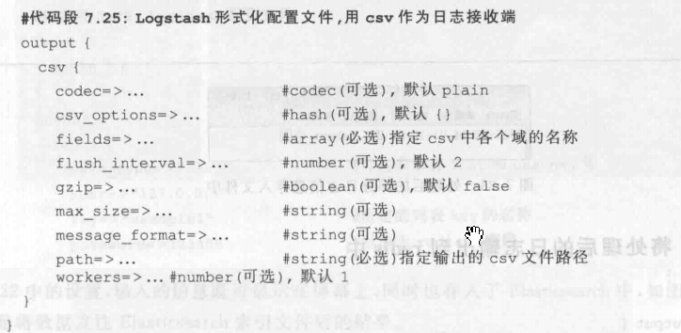



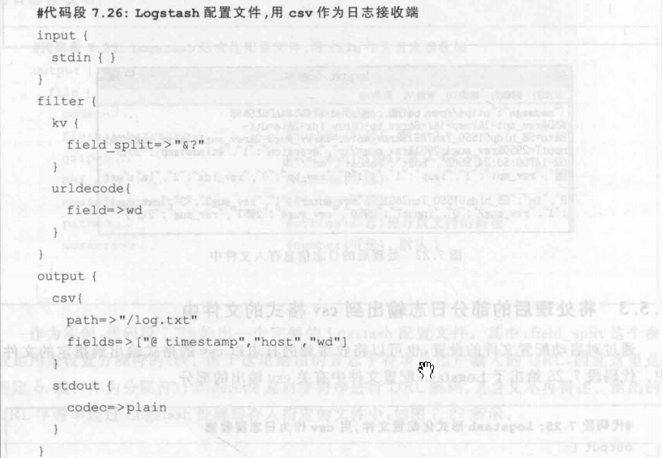

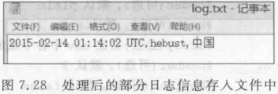

### 4 输出到redis中

<https://www.elastic.co/guide/en/logstash/current/plugins-outputs-redis.html>

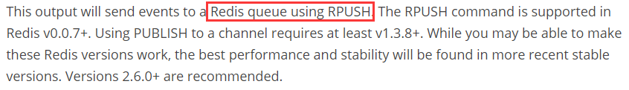

| **Setting** | **Input type** | **Required** |
| --- | --- | --- |
| [batch](https://www.elastic.co/guide/en/logstash/current/plugins-outputs-redis.html" \l "plugins-outputs-redis-batch" \o "batch) | [boolean](https://www.elastic.co/guide/en/logstash/current/configuration-file-structure.html" \l "boolean" \o "Booleanedit) | No |
| [batch\_events](https://www.elastic.co/guide/en/logstash/current/plugins-outputs-redis.html" \l "plugins-outputs-redis-batch_events" \o "batch_events) | [number](https://www.elastic.co/guide/en/logstash/current/configuration-file-structure.html" \l "number" \o "Numberedit) | No |
| [batch\_timeout](https://www.elastic.co/guide/en/logstash/current/plugins-outputs-redis.html" \l "plugins-outputs-redis-batch_timeout" \o "batch_timeout) | [number](https://www.elastic.co/guide/en/logstash/current/configuration-file-structure.html" \l "number" \o "Numberedit) | No |
| [congestion\_interval](https://www.elastic.co/guide/en/logstash/current/plugins-outputs-redis.html" \l "plugins-outputs-redis-congestion_interval" \o "congestion_interval) | [number](https://www.elastic.co/guide/en/logstash/current/configuration-file-structure.html" \l "number" \o "Numberedit) | No |
| [congestion\_threshold](https://www.elastic.co/guide/en/logstash/current/plugins-outputs-redis.html" \l "plugins-outputs-redis-congestion_threshold" \o "congestion_threshold) | [number](https://www.elastic.co/guide/en/logstash/current/configuration-file-structure.html" \l "number" \o "Numberedit) | No |
| [data\_type](https://www.elastic.co/guide/en/logstash/current/plugins-outputs-redis.html" \l "plugins-outputs-redis-data_type" \o "data_type) | [string](https://www.elastic.co/guide/en/logstash/current/configuration-file-structure.html" \l "string" \o "Stringedit), one of ["list", "channel"] | No |
| [db](https://www.elastic.co/guide/en/logstash/current/plugins-outputs-redis.html" \l "plugins-outputs-redis-db" \o "db) | [number](https://www.elastic.co/guide/en/logstash/current/configuration-file-structure.html" \l "number" \o "Numberedit) | No |
| [host](https://www.elastic.co/guide/en/logstash/current/plugins-outputs-redis.html" \l "plugins-outputs-redis-host" \o "host) | [array](https://www.elastic.co/guide/en/logstash/current/configuration-file-structure.html" \l "array" \o "Array) | No |
| [key](https://www.elastic.co/guide/en/logstash/current/plugins-outputs-redis.html" \l "plugins-outputs-redis-key" \o "key) | [string](https://www.elastic.co/guide/en/logstash/current/configuration-file-structure.html" \l "string" \o "Stringedit) | No |
| [password](https://www.elastic.co/guide/en/logstash/current/plugins-outputs-redis.html" \l "plugins-outputs-redis-password" \o "password) | [password](https://www.elastic.co/guide/en/logstash/current/configuration-file-structure.html" \l "password" \o "Passwordedit) | No |
| [port](https://www.elastic.co/guide/en/logstash/current/plugins-outputs-redis.html" \l "plugins-outputs-redis-port" \o "port) | [number](https://www.elastic.co/guide/en/logstash/current/configuration-file-structure.html" \l "number" \o "Numberedit) | No |
| [reconnect\_interval](https://www.elastic.co/guide/en/logstash/current/plugins-outputs-redis.html" \l "plugins-outputs-redis-reconnect_interval" \o "reconnect_interval) | [number](https://www.elastic.co/guide/en/logstash/current/configuration-file-structure.html" \l "number" \o "Numberedit) | No |
| [shuffle\_hosts](https://www.elastic.co/guide/en/logstash/current/plugins-outputs-redis.html" \l "plugins-outputs-redis-shuffle_hosts" \o "shuffle_hosts) | [boolean](https://www.elastic.co/guide/en/logstash/current/configuration-file-structure.html" \l "boolean" \o "Booleanedit) | No |
| [timeout](https://www.elastic.co/guide/en/logstash/current/plugins-outputs-redis.html" \l "plugins-outputs-redis-timeout" \o "timeout) | [number](https://www.elastic.co/guide/en/logstash/current/configuration-file-structure.html" \l "number" \o "Numberedit) | No |

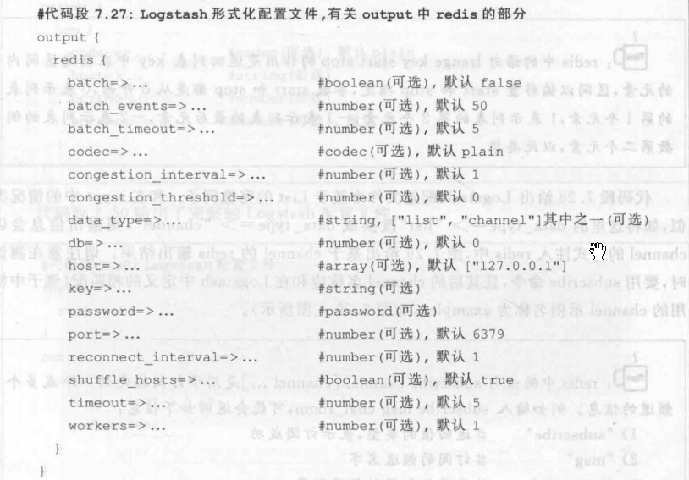

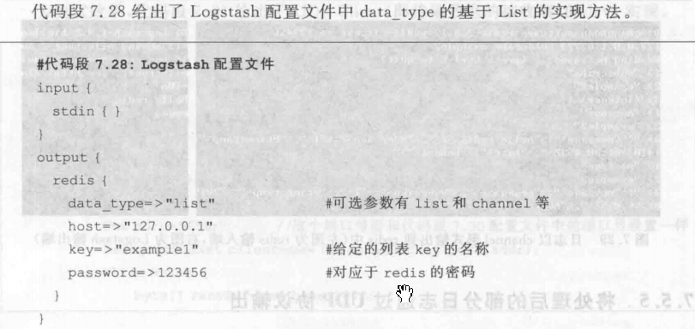

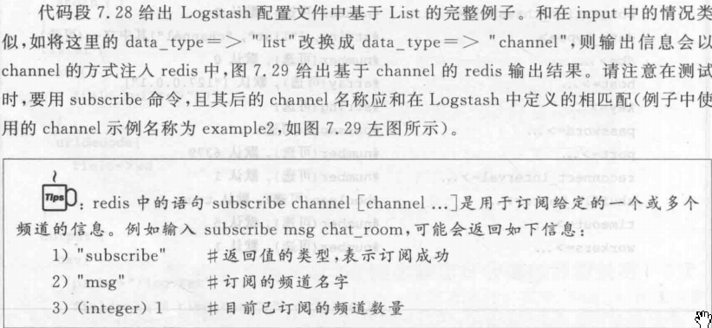

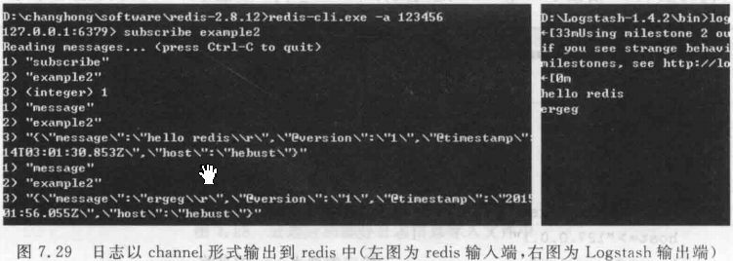

### 5 通过UDP协议输出

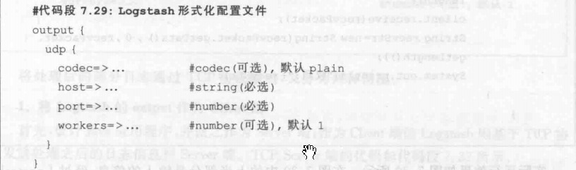

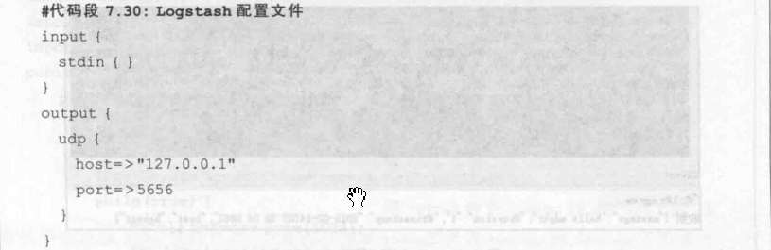

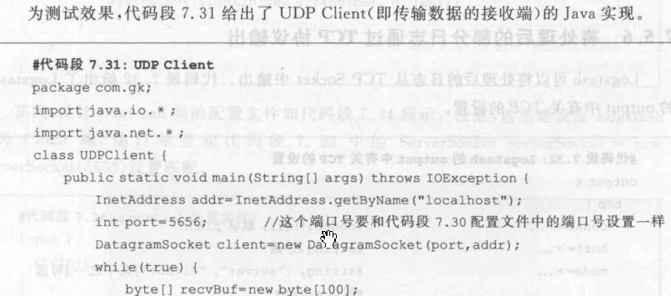

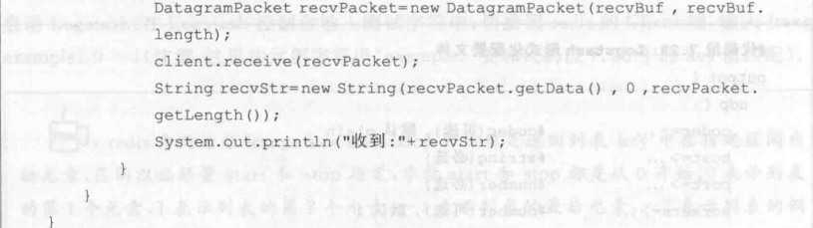

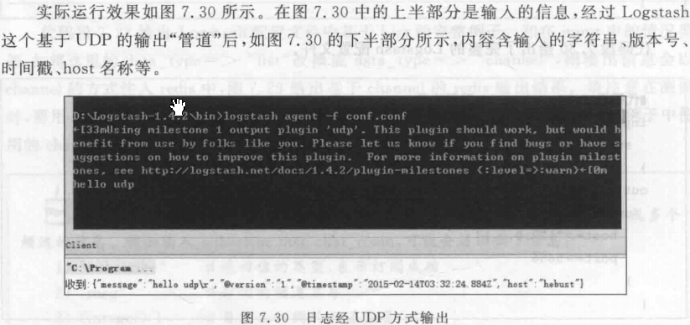

### 6 通过TCP协议输出

<https://www.elastic.co/guide/en/logstash/current/plugins-outputs-tcp.html>

| **Setting** | **Input type** | **Required** |
| --- | --- | --- |
| [host](https://www.elastic.co/guide/en/logstash/current/plugins-outputs-tcp.html" \l "plugins-outputs-tcp-host" \o "host) | [string](https://www.elastic.co/guide/en/logstash/current/configuration-file-structure.html" \l "string" \o "Stringedit) | Yes |
| [mode](https://www.elastic.co/guide/en/logstash/current/plugins-outputs-tcp.html" \l "plugins-outputs-tcp-mode" \o "mode) | [string](https://www.elastic.co/guide/en/logstash/current/configuration-file-structure.html" \l "string" \o "Stringedit), one of ["server", "client"] | No |
| [port](https://www.elastic.co/guide/en/logstash/current/plugins-outputs-tcp.html" \l "plugins-outputs-tcp-port" \o "port) | [number](https://www.elastic.co/guide/en/logstash/current/configuration-file-structure.html" \l "number" \o "Numberedit) | Yes |
| [reconnect\_interval](https://www.elastic.co/guide/en/logstash/current/plugins-outputs-tcp.html" \l "plugins-outputs-tcp-reconnect_interval" \o "reconnect_interval) | [number](https://www.elastic.co/guide/en/logstash/current/configuration-file-structure.html" \l "number" \o "Numberedit) | No |
| [ssl\_cacert](https://www.elastic.co/guide/en/logstash/current/plugins-outputs-tcp.html" \l "plugins-outputs-tcp-ssl_cacert" \o "ssl_cacert) | a valid filesystem path | No |
| [ssl\_cert](https://www.elastic.co/guide/en/logstash/current/plugins-outputs-tcp.html" \l "plugins-outputs-tcp-ssl_cert" \o "ssl_cert) | a valid filesystem path | No |
| [ssl\_enable](https://www.elastic.co/guide/en/logstash/current/plugins-outputs-tcp.html" \l "plugins-outputs-tcp-ssl_enable" \o "ssl_enable) | [boolean](https://www.elastic.co/guide/en/logstash/current/configuration-file-structure.html" \l "boolean" \o "Booleanedit) | No |
| [ssl\_key](https://www.elastic.co/guide/en/logstash/current/plugins-outputs-tcp.html" \l "plugins-outputs-tcp-ssl_key" \o "ssl_key) | a valid filesystem path | No |
| [ssl\_key\_passphrase](https://www.elastic.co/guide/en/logstash/current/plugins-outputs-tcp.html" \l "plugins-outputs-tcp-ssl_key_passphrase" \o "ssl_key_passphrase) | [password](https://www.elastic.co/guide/en/logstash/current/configuration-file-structure.html" \l "password" \o "Passwordedit) | No |
| [ssl\_verify](https://www.elastic.co/guide/en/logstash/current/plugins-outputs-tcp.html" \l "plugins-outputs-tcp-ssl_verify" \o "ssl_verify) | [boolean](https://www.elastic.co/guide/en/logstash/current/configuration-file-structure.html" \l "boolean" \o "Booleanedit) | No |

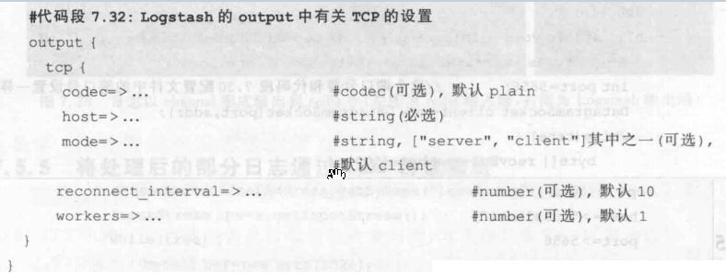

#### 1 Logstash的output作为Client端

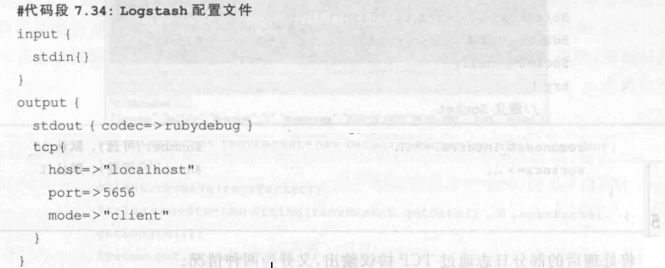

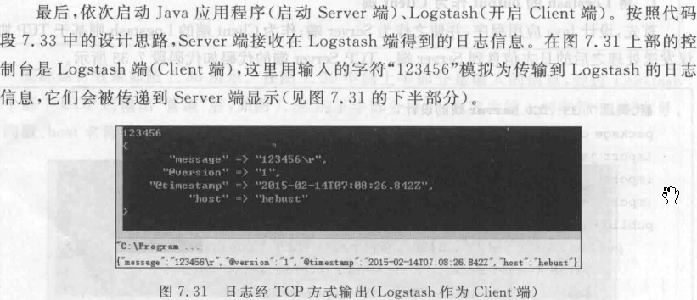

#### 2 Logstash的output作为server端

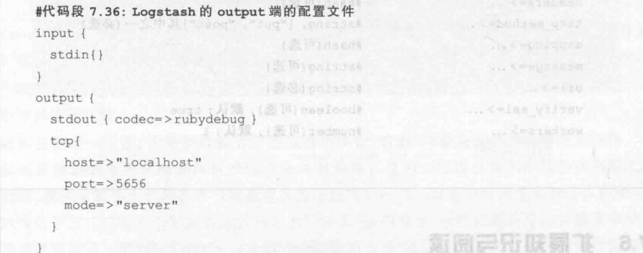

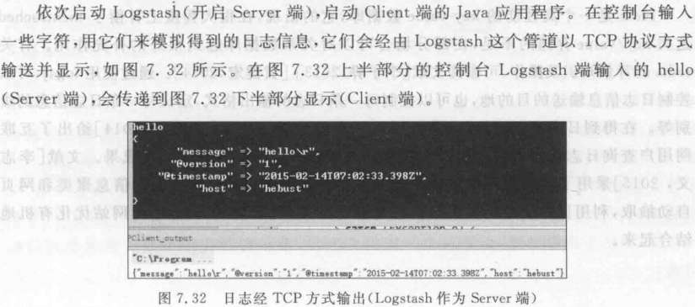

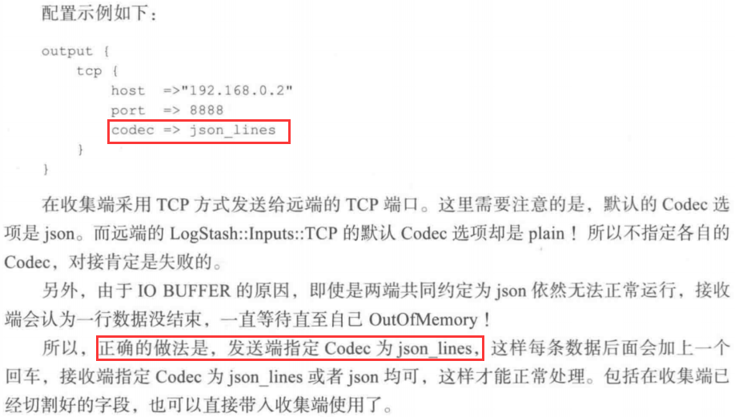

### 7 输出到自定义的HTTP接口中

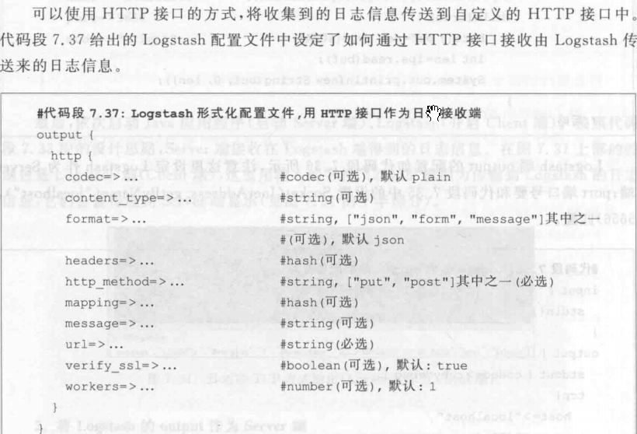

### 8 webhdfs 输出到hdfs

<https://www.elastic.co/guide/en/logstash/current/plugins-outputs-webhdfs.html>

input {

...

}

filter {

...

}

output {

webhdfs {

host => "127.0.0.1" # (required)

port => 50070 # (optional, default: 50070)

path => "/user/logstash/dt=%{+YYYY-MM-dd}/logstash-%{+HH}.log" # (required)

user => "hue" # (required)

}

}

| **Setting** | **Input type** | **Required** |
| --- | --- | --- |
| [compression](https://www.elastic.co/guide/en/logstash/current/plugins-outputs-webhdfs.html" \l "plugins-outputs-webhdfs-compression" \o "compression) | [string](https://www.elastic.co/guide/en/logstash/current/configuration-file-structure.html" \l "string" \o "Stringedit), one of ["none", "snappy", "gzip"] | No |
| [flush\_size](https://www.elastic.co/guide/en/logstash/current/plugins-outputs-webhdfs.html" \l "plugins-outputs-webhdfs-flush_size" \o "flush_size) | [number](https://www.elastic.co/guide/en/logstash/current/configuration-file-structure.html" \l "number" \o "Numberedit) | No |
| [host](https://www.elastic.co/guide/en/logstash/current/plugins-outputs-webhdfs.html" \l "plugins-outputs-webhdfs-host" \o "host) | [string](https://www.elastic.co/guide/en/logstash/current/configuration-file-structure.html" \l "string" \o "Stringedit) | Yes |
| [idle\_flush\_time](https://www.elastic.co/guide/en/logstash/current/plugins-outputs-webhdfs.html" \l "plugins-outputs-webhdfs-idle_flush_time" \o "idle_flush_time) | [number](https://www.elastic.co/guide/en/logstash/current/configuration-file-structure.html" \l "number" \o "Numberedit) | No |
| [kerberos\_keytab](https://www.elastic.co/guide/en/logstash/current/plugins-outputs-webhdfs.html" \l "plugins-outputs-webhdfs-kerberos_keytab" \o "kerberos_keytab) | [string](https://www.elastic.co/guide/en/logstash/current/configuration-file-structure.html" \l "string" \o "Stringedit) | No |
| [open\_timeout](https://www.elastic.co/guide/en/logstash/current/plugins-outputs-webhdfs.html" \l "plugins-outputs-webhdfs-open_timeout" \o "open_timeout) | [number](https://www.elastic.co/guide/en/logstash/current/configuration-file-structure.html" \l "number" \o "Numberedit) | No |
| [path](https://www.elastic.co/guide/en/logstash/current/plugins-outputs-webhdfs.html" \l "plugins-outputs-webhdfs-path" \o "path) | [string](https://www.elastic.co/guide/en/logstash/current/configuration-file-structure.html" \l "string" \o "Stringedit) | Yes |
| [port](https://www.elastic.co/guide/en/logstash/current/plugins-outputs-webhdfs.html" \l "plugins-outputs-webhdfs-port" \o "port) | [number](https://www.elastic.co/guide/en/logstash/current/configuration-file-structure.html" \l "number" \o "Numberedit) | No |
| [read\_timeout](https://www.elastic.co/guide/en/logstash/current/plugins-outputs-webhdfs.html" \l "plugins-outputs-webhdfs-read_timeout" \o "read_timeout) | [number](https://www.elastic.co/guide/en/logstash/current/configuration-file-structure.html" \l "number" \o "Numberedit) | No |
| [retry\_interval](https://www.elastic.co/guide/en/logstash/current/plugins-outputs-webhdfs.html" \l "plugins-outputs-webhdfs-retry_interval" \o "retry_interval) | [number](https://www.elastic.co/guide/en/logstash/current/configuration-file-structure.html" \l "number" \o "Numberedit) | No |
| [retry\_known\_errors](https://www.elastic.co/guide/en/logstash/current/plugins-outputs-webhdfs.html" \l "plugins-outputs-webhdfs-retry_known_errors" \o "retry_known_errors) | [boolean](https://www.elastic.co/guide/en/logstash/current/configuration-file-structure.html" \l "boolean" \o "Booleanedit) | No |
| [retry\_times](https://www.elastic.co/guide/en/logstash/current/plugins-outputs-webhdfs.html" \l "plugins-outputs-webhdfs-retry_times" \o "retry_times) | [number](https://www.elastic.co/guide/en/logstash/current/configuration-file-structure.html" \l "number" \o "Numberedit) | No |
| [single\_file\_per\_thread](https://www.elastic.co/guide/en/logstash/current/plugins-outputs-webhdfs.html" \l "plugins-outputs-webhdfs-single_file_per_thread" \o "single_file_per_thread) | [boolean](https://www.elastic.co/guide/en/logstash/current/configuration-file-structure.html" \l "boolean" \o "Booleanedit) | No |
| [snappy\_bufsize](https://www.elastic.co/guide/en/logstash/current/plugins-outputs-webhdfs.html" \l "plugins-outputs-webhdfs-snappy_bufsize" \o "snappy_bufsize) | [number](https://www.elastic.co/guide/en/logstash/current/configuration-file-structure.html" \l "number" \o "Numberedit) | No |
| [snappy\_format](https://www.elastic.co/guide/en/logstash/current/plugins-outputs-webhdfs.html" \l "plugins-outputs-webhdfs-snappy_format" \o "snappy_format) | [string](https://www.elastic.co/guide/en/logstash/current/configuration-file-structure.html" \l "string" \o "Stringedit), one of ["stream", "file"] | No |
| [ssl\_cert](https://www.elastic.co/guide/en/logstash/current/plugins-outputs-webhdfs.html" \l "plugins-outputs-webhdfs-ssl_cert" \o "ssl_cert) | [string](https://www.elastic.co/guide/en/logstash/current/configuration-file-structure.html" \l "string" \o "Stringedit) | No |
| [ssl\_key](https://www.elastic.co/guide/en/logstash/current/plugins-outputs-webhdfs.html" \l "plugins-outputs-webhdfs-ssl_key" \o "ssl_key) | [string](https://www.elastic.co/guide/en/logstash/current/configuration-file-structure.html" \l "string" \o "Stringedit) | No |
| [standby\_host](https://www.elastic.co/guide/en/logstash/current/plugins-outputs-webhdfs.html" \l "plugins-outputs-webhdfs-standby_host" \o "standby_host) | [string](https://www.elastic.co/guide/en/logstash/current/configuration-file-structure.html" \l "string" \o "Stringedit) | No |
| [standby\_port](https://www.elastic.co/guide/en/logstash/current/plugins-outputs-webhdfs.html" \l "plugins-outputs-webhdfs-standby_port" \o "standby_port) | [number](https://www.elastic.co/guide/en/logstash/current/configuration-file-structure.html" \l "number" \o "Numberedit) | No |
| [use\_httpfs](https://www.elastic.co/guide/en/logstash/current/plugins-outputs-webhdfs.html" \l "plugins-outputs-webhdfs-use_httpfs" \o "use_httpfs) | [boolean](https://www.elastic.co/guide/en/logstash/current/configuration-file-structure.html" \l "boolean" \o "Booleanedit) | No |
| [use\_kerberos\_auth](https://www.elastic.co/guide/en/logstash/current/plugins-outputs-webhdfs.html" \l "plugins-outputs-webhdfs-use_kerberos_auth" \o "use_kerberos_auth) | [boolean](https://www.elastic.co/guide/en/logstash/current/configuration-file-structure.html" \l "boolean" \o "Booleanedit) | No |
| [use\_ssl\_auth](https://www.elastic.co/guide/en/logstash/current/plugins-outputs-webhdfs.html" \l "plugins-outputs-webhdfs-use_ssl_auth" \o "use_ssl_auth) | [boolean](https://www.elastic.co/guide/en/logstash/current/configuration-file-structure.html" \l "boolean" \o "Booleanedit) | No |
| [user](https://www.elastic.co/guide/en/logstash/current/plugins-outputs-webhdfs.html" \l "plugins-outputs-webhdfs-user" \o "user) | [string](https://www.elastic.co/guide/en/logstash/current/configuration-file-structure.html" \l "string" \o "Stringedit) | Yes |

## 拓展方案

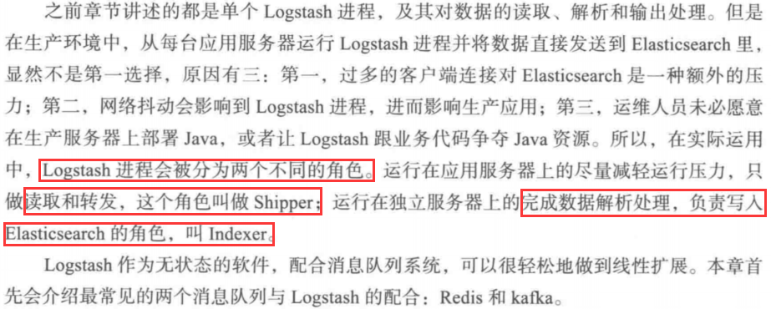

### 1 通过redis队列扩展

### 2 通过Kafka队列扩展

<https://www.elastic.co/guide/en/logstash/current/plugins-inputs-kafka.html>

<https://www.elastic.co/guide/en/logstash/current/plugins-outputs-kafka.html>

### 3 Nxlog

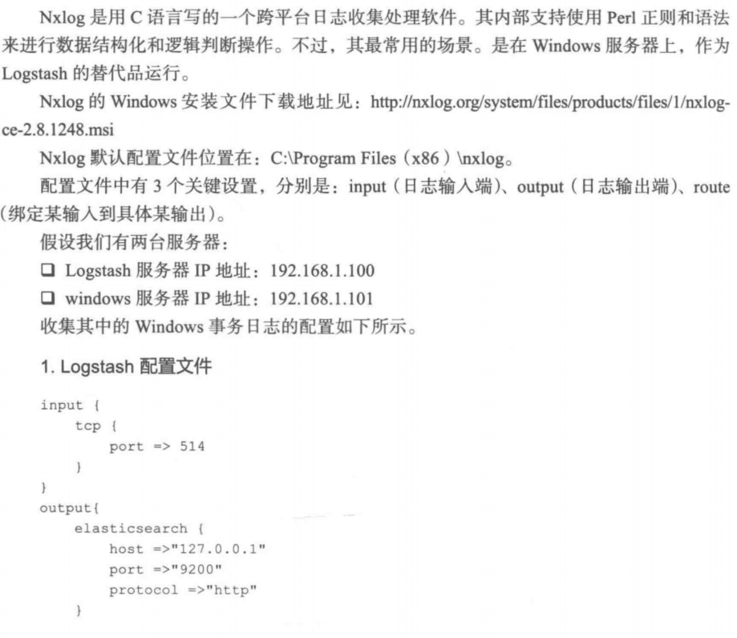

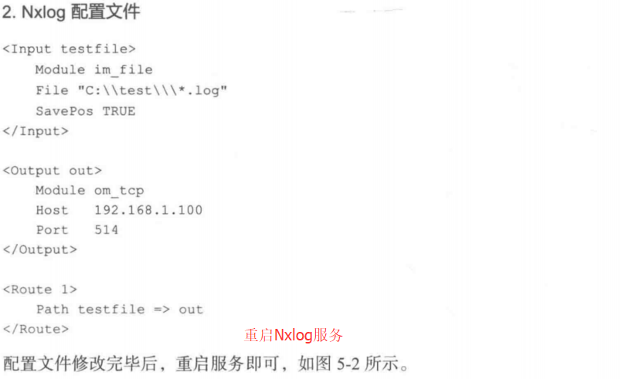

## Beats

